




From EVIDENCE to PRACTICE:

Goal Achievement in CalWORKs 2.0
February 2019
CalWORKs 2.0 Strategic Initiative Team
Facilitator Guide

Contents
Introduction 1
The Science Underlying CalWORKs 2.0: A Reference for Facilitators 2
Design and Facilitation of the Modules 3
Module One Building Adult Capabilities 5
BEFORE THE WORKSHOP 6
WORKSHOP 6
RECOMMENDED FOLLOW-UP 9
CALWORKS 2.0 TOOLS / RESOURCES 9
Building Core Capabilities for Life: Video Viewing Guide 10
Context Matters: How Living in Poverty Impacts Adult Capabilities 13
Adult Capabilities | Real Life Stories – Facilitator answers 14
What Can Counties Do? 16
Module Two Addressing Scarcity 17
BEFORE THE WORKSHOP 18
WORKSHOP 18
RECOMMENDED FOLLOW-UP 21
Selected CalWORKs 2.0 Tools/Resources: 21
TUNNEL VISION | Scarcity and How it Shapes Us 21
A Mind Map 23
A Scarcity Overview - In Quotes 24
Scarcity Stories 25
Scarcity Scenarios | For Small Groups 26
What We Can Do 28
Module Three Coaching in Client Interactions 29
BEFORE THE WORKSHOP 30
WORKSHOP 30
RECOMMENDED FOLLOW-UP 33
Module 3 Viewing Guide: A Motivational Interviewing Resource Video Viewing Guide 34
Coaching Methods 35
Strengths-Based Approach 36
Trauma-Informed Care 38
Motivational Interviewing 40
Client Biography 41
Module Four The Art and Science of Goal Achievement 42
BEFORE THE WORKSHOP 43
WORKSHOP 43
RECOMMENDED FOLLOW-UP 45
CALWORKS 2.0 TOOLS/RESOURCES 45
The Art and Science of Goal Achievement: Preparation 46
Goal, Plan, Do, Review, and Revise: An Executive-Function Informed Goal Achievement Framework 47
The Path to Goal Achievement: Goal, Plan, Do, Review, and Revise 51
The Language of Goal Achievement 52
Module Five Coaching With the Calworks 2.0 tools 53
BEFORE THE WORKSHOP 54
WORKSHOP 54
RECOMMENDED FOLLOW-UP 57
CALWORKS 2.0 TOOLS/RESOURCES USED IN THIS MODULE 57
How GPDR/R Differs from Common Practices 58
Using Coaching Methods in Meetings with Clients 59
Plan to Use Tools with Clients 64

Introduction
Introducing these modules to your colleagues
The text on this page is meant to serve as a reference for you to describe these modules to colleagues. Feel free to use your own words and frame these in a way that will be most relevant to staff in your program.
The purpose of this learning series
- The main purpose of this learning series is for CalWORKs employment services and related staff to explore the evidence base that underlies CalWORKs 2.0 and see how it applies to their everyday work. We will look at key concepts related to adult capabilities and behavioral science in order to broaden staff's perspective on the participant experience and to put on the brain science “lens” when interacting with customers.
- These modules provide staff with an opportunity for deep discussion about how to best integrate this new approach into their employment service and related programs – the information in these modules is the compelling force behind much of the CalWORKs 2.0 Culture Change.
- Through the workshops, staff will be introduced to a select set of the tools that have been developed for CalWORKs 2.0. These workshops will not focus on teaching staff how to use those tools effectively with clients -- however they do intend to set them up for success in using the tools by deeply exploring the “why” behind them.
- All of the modules will be built on effective adult learning principles and practices.
- Staff will lead these modules with colleagues in their counties. The workshops are designed to be led in groups, with dialogue among staff. Staff in any position within a program will have an opportunity to reflect on how this evidence translates to practice in their unique setting and role.
Objectives
By the end of the set of workshops, participating staff will have accomplished the following:
- Described ways that the evidence underlying CalWORKs 2.0 affirms and validates what you’ve discovered through practice
- Identified ways in which the evidence underlying CalWORKs 2.0 expands your understanding of the strengths and the constraints participants face
- Reflected on the intent of selected CalWORKs 2.0 (county and frontline) tools
- Named concrete ways in which this evidence base might be useful to you in your role currently
The Science Underlying CalWORKs 2.0
These modules are not the sole training package for CalWORKs 2.0. Rather, they focus specifically on helping staff internalize and apply the evidence that inspired and guided CalWORKs 2.0. The following summary page may be a handy reference to you as facilitator of the modules. We also highly encourage exploring some of the wonderful resources on your website: calworksnextgen.org. The full suite of materials to implement and train on CalWORKs 2.0 include, (1) The County Level Guide; (2) The Frontline Staff Guide; (3) The series of CalWORKs 2.0 Webinars and Newsletters; (4) Tool-specific training videos, (5) The CalWORKsNextGen.org website; and (6) this Evidence to Practice Training.

The Science Underlying CalWORKs 2.0: A Reference for Facilitators
Sharing this Science with Colleagues
This page summarizes the core evidence that inspired these modules – and CalWORKs 2.0 more broadly. You may use it as a reference for yourself before facilitating the modules and may share it in whole or in parts with colleagues as you see fit.
Adult Capabilities
- Core adult capabilities support our ability to focus, plan for and achieve goals, adapt to changing situations, and resist impulsive behaviors. We need these skills to manage life, work, and relationships successfully.
- No one is born with these skills; they are developed over time through coaching and practice.
- We all have strengths and weaknesses in these core skills - the more we know about them, the better we can support our own goal achievement.
- Stress affects these skills in both the short term and long term (how well we can organize, plan, and monitor our actions).
- Truly supportive relationships (instead of directive or transactional) help us make choices that are meaningful and that lower our stress.
Scarcity of Resources and Time (from Behavioral Science)
- We can only perceive, process, and act on a fixed amount of information at any given moment (This is described as “limited bandwidth”).
- When we have too much going on, we can lose sight of important future concerns and tasks to laser-focus on whatever is most urgent today.
- When we focus on the immediate, important things get neglected and it is hard to see the big picture.
- When we are really stressed, it is helpful for others to remind us to step back and look at the bigger picture. It is also helpful for them to provide support such as helping with paperwork or reducing the steps we have to take to fulfill a goal.
- We can see and digest important information better when it is brief and stands out from the “noise.”
- Organizations have a role to play in simplifying processes, providing resources to reduce scarcity, and being very careful of how and what information is presented.
Goal Achievement
- How we approach goal achievement matters- the process is key to being effective. Goal achievement as an evidence-based practice is about following the scientific evidence at each step in the process.
- Choosing goals that are meaningful to us bolsters our motivation. We know that motivation is highly related to having a choice and feeling in control.
- We are more likely to achieve a goal if (1) it is specific and short-term and (2) we think through pitfalls before they happen.
We build skills and confidence by achieving goals of any sort and sequencing many small successes.
How Adults Learn
- In order to learn something new, we need to do something with it (apply it).
- Learning happens when we are free to focus on what is most relevant to us right now.
- Modeling is a key strategy for us to teach different behavior to someone else.

Design and Facilitation of the Modules
An Intentional Structure for All of the Modules
As depicted on the previous page, this package includes five modules with a suggested sequence. We envision that you lead each of the five modules at separate times, so that staff have time to prepare for and focus on each one in turn. Each module is estimated to be about two (2) hours.
The body of the workshops all follow a similar, intentional structure. You can remember this structure with the acronym REAL.
- R: Reflect to ground staff in the topic
- E: Explore key content
- A: Apply and make meaning of key content
- L: Leave with practical ideas about how to carry our learning to our day-to-day work.
The structure is based on an understanding of learning as a continuous, iterative cycle of action and reflection. When you adapt these workshops, you may get creative about how you guide people through this cycle, but evidence would suggest that you open with a reflective, grounding activity and have them leave with practical ideas for the future. We suggest telling participants the overall structure of each module, so that the intentionality of each step is clear as they move through the workshop with you. For example, you might say “We’ve just finished our opening reflection and will begin to explore key content together.”
Self-Directed Learning for Participants Before and After the Workshop
Preparation and follow-up by the participants of these workshops is key to the learning. Why? Because learning that happens in a workshop often stays in a workshop. We want to create a bridge from and to staff’s day-to-day work. Each module offers a preparatory activity that creates a “scaffold” of learning upon which the content of the workshop will hang. Each module also offers some ideas for follow-up activities so that staff can recall the content of the workshop in their day-to-day work, and begin to use it where it can really make a difference.
In short, don’t skip the preparation or follow-up. When you schedule your workshops, we encourage you to also schedule a communication to staff about one week prior (with the preparatory activity) and one week after (with follow-up reminders).
Adapting the modules to your context
You know your county’s unique context, program, and staff. In keeping with research on adult learning, we strongly encourage you to adapt the content of the modules based on (1) what your staff already know and do well and (2) your program’s greatest interests and opportunities for improvement. When you make adaptations, we encourage you to preserve the “REAL” structure described above since this provides staff with a complete learning experience around each topic.
Adult Learning Principles and a “Learning-Centered Approach”
These modules were created using an approach that shifts the focus from teaching to learning. It is subtle but powerful. You are probably already using many elements of this approach in your program without necessarily calling it that! You can read more about the learning-centered approach (and how it differs from a teacher- or learner-centered approach) here.
At the heart of the approach are five core principles that we encourage you to keep in mind as you review, and adapt, these modules. We’ve got another acronym to help you keep them top-of-mind: REACH: Relevant, Engaging, Actionable, Clear, and Holistic.
FIVE ADULT LEARNING PRINCIPLES: REACH™
- Relevant: Participants personally connect with the content and name how it might be useful in their life now.
- Engaging: Participants have ample opportunity to interact with each other by sharing examples, challenges, and insights.
- Actionable: The teaching supports people to take action (i.e., goes beyond “taking in” information to actually “taking action” with that information).
- Clear: The language, examples, and directions you offer are extremely easy for the user. Plain language and visuals are used throughout.
- Holistic: The teaching addresses the learners’ mind (ideas), heart (feelings), and body (abilities).
Check out www.globalearningpartners.com for more insights and free downloadable resources on the topics of learning assessment, design, facilitation, or evaluation.
Visual Guide
The icons below have been used to help you identify what type of activity you will be doing in each section of the modules.
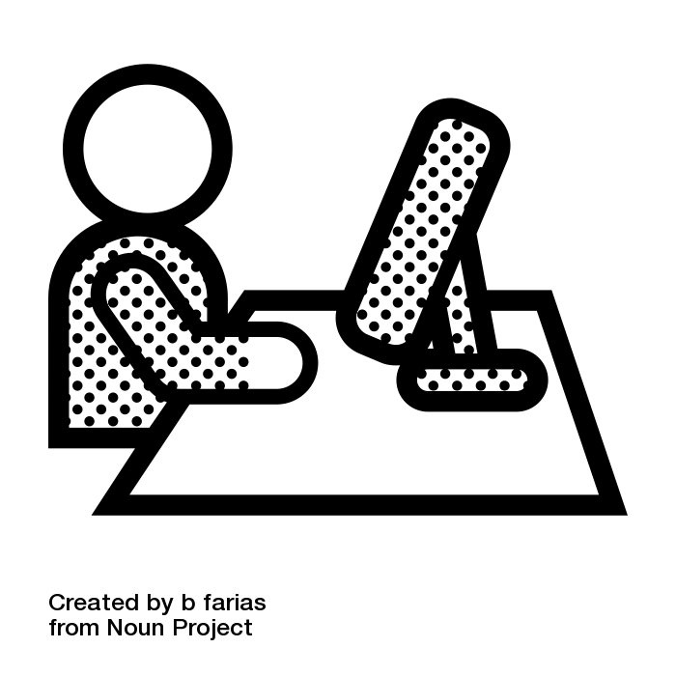 indicates sending email to participants before and after workshop module
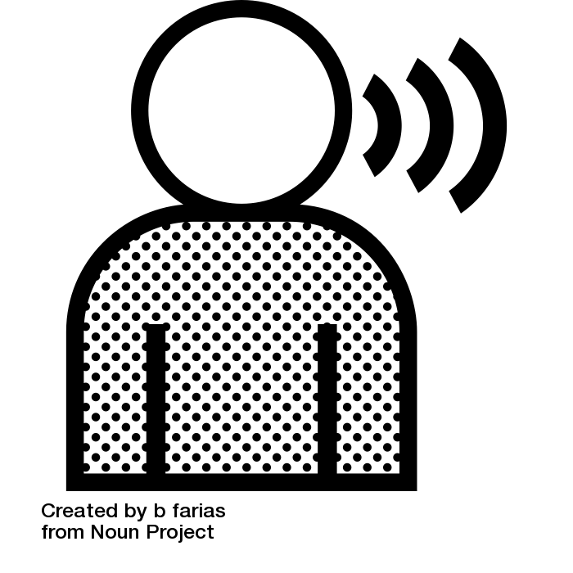 indicates you, the facilitator, speaking or explaining
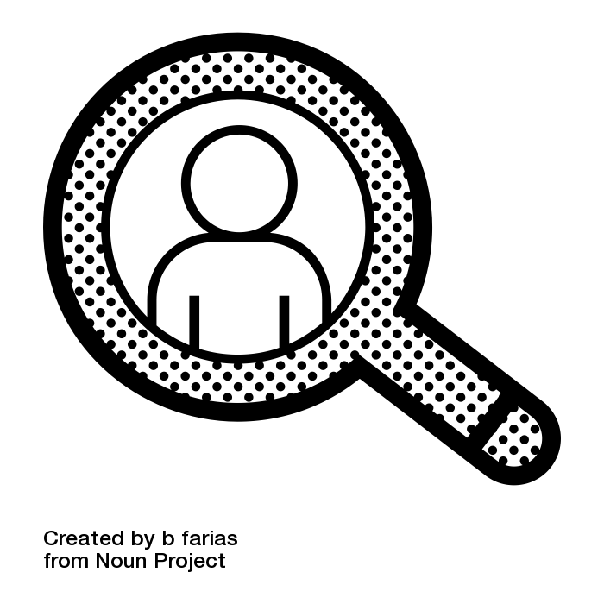 indicates self-reflection for participants
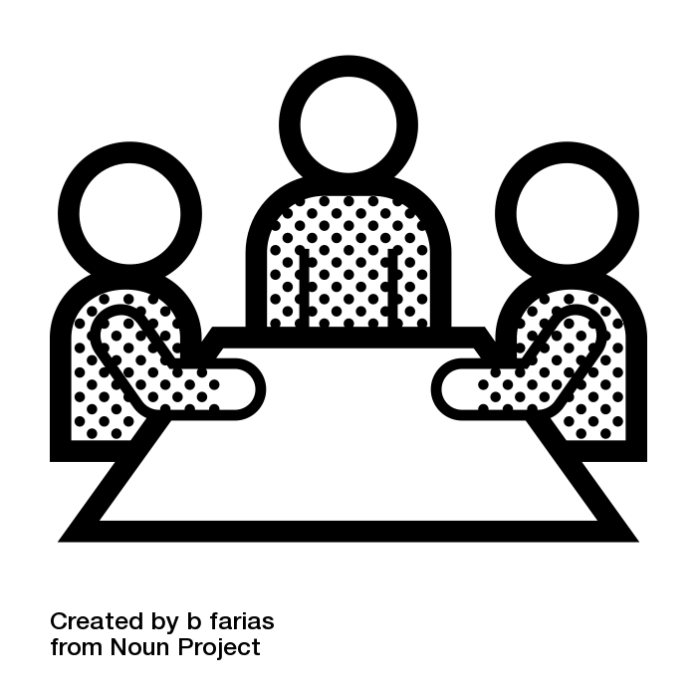 indicates small group work
 indicates there is a handout used in activity

Module One
Building Adult Capabilities

Module One: Building Adult Capabilities

BEFORE THE WORKSHOP
One week prior to the workshop send the attached Module 1 Viewer’s Guide to your staff with a link to a 5-minute video they can watch before the workshop.

WORKSHOP

Introduction (5 min.)
Explain: Today’s workshop focuses on core adult capabilities - also known as Executive Function skills. In today’s workshop, we’ll take an up-close-and-personal look at these skills, explore how these skills show up in life, and exchange ideas about how a greater awareness of these skills can strengthen our program and support our clients.

Reflect | Building Adult Capabilities (25 min.)
Explain: A growing body of research highlights the important role that adult capabilities play in helping adults achieve success in the workplace and at home.
Adult capabilities:
(1) help us to carry out day-to-day tasks and achieve life goals that are important and meaningful to us;
(2) help us plan, control our responses to positive and negative exposures, and monitor our actions for social appropriateness and the best possible outcomes;
(3) help us to remember important information and follow multi-step processes or instructions.
These capabilities first develop in early childhood and their natural development ends at about the mid 20’s. It is important to recognize how different models, experiences, limitations, circumstances, and privileges in life can shape our ability to develop these skills (we now know that the old ‘pull yourself up by your bootstraps’ story is a false narrative). However, the good news for all of us is that they can be improved through practice and gained throughout adulthood. All adults have strengths and weaknesses in these skills. Our weaknesses will show up more at times of stress; and our strengths will emerge in times of stability.

Show the video titled “Building Core Capabilities” from the Harvard Center on the Developing Child. Acknowledge that many staff have already seen the video, but that by watching again they are likely to view new angles and deepen their grasp on adult capabilities. After watching the video, call people’s attention to the Video Viewing Guide. Explain that this serves as a reminder of key parts of the video and therefore is useful prompt for the group discussion.
What stood out for you in this video and why? What questions do you have that we might explore together?

Explore | Our Personal Strengths and Weaknesses (30 min)
As a group, walk through handout: What Are Adult Capabilities? Explain briefly that different researchers and practitioners describe these capabilities in slightly different ways. One practical way to think about them is a set of a dozen (12) capabilities–or skills–that fall into three groupings.
The color coding in the handout indicate these groupings as (1)Planning, (2)Self-Control, and (3)Monitoring. We all use these skills in a number of ways every day. The next handout provides a brief description of each skill and illlustrates how inter-related some of these skills are.
Clarify questions, briefly.
Call people’s attention to the worksheet: Executive Skills Defined. Invite everyone to explore their own personal strengths and weakesses by using the following open questions. Make sure everyone has a highlighter or pen to mark up the worksheet (3 strengths and 3 weaknesses). Leave ample time for discussion, and note that staff consider the questions for either “home” or “work” as the two sets might look different in different environments.
- Which three (3) skills do you see as your greatest strengths? What pattern, if any, do you see across these strengths? What is one example of how you’ve USED this strength in the past week?
- Which three (3) skills do you see as your greatest weaknesses? What pattern, if any, do you see across these weaknesses? What is one example of a time when this weakness LIMITED you this past week? What strategies did you use for support?
Invite trios to exchange their insights, based on their personal responses to the questions above. You do not need to bring the conversation to full group.
In full group, review the handout Context Matters. Invite individual or small group reflection:
Given your role in the program, what does this research say to you?

Apply | How Capabilities Show Up in Real Life (30 min)
At this part of the workshop, staff apply the concept of executive skills to their everyday interactions. To do this, we recommend using the handout: Real Life Stories, along with the reference: Executive Skills Defined.
You can decide on a creative, energetic way for the group to “match” each vignette to each executive skill. Here are two ideas for how to do that. Whatever you do, make sure that staff have ample time to think about the story – and thoughtfully consider the possible skills operating in that story.
- Buzzer: Mix up the tables into new teams. Have each team choose a sound on one person’s smartphone that they’ll use as their buzzer when they have an answer to call out (settings/sounds). Read each vignette aloud and hear the answer from the first team that buzzes. Move through each of the 12 vignettes.
Matching: Create a large chart with the titles of each of the 12 skills (make sure it looks like their handout in terms of the placement of the skills on the grid). After reading each vignette, wait while the teams “compete” to decide which one skill is most strongly operating in this vignette. Once the table has decided, they “run” to the grid on the wall to place a sticky note (or a mark) on that skill.
Before moving on to talking about CalWORKs clients, field any questions about how the skills show up in real life. Underscore the importance of seeing both strengths and weaknesses in others (the subtle differences among some of them can be important in terms of how you support a client.)
As time allows, think of one client in your program now.
- What is a goal they are pursuing?
- What do you see as a significant strength? How might they make better use of that strength to achieve their goal?
- What do you see as a significant weakness? What strategies might support that weakness?
In full group, describe some of the insights you got into tapping people’s strengths, or supporting people’s weaknesses.
Research on adult capabilities has been applied to the design of CalWORKs 2.0 in many ways. For example, many of the frontline tools were designed to support a routine approach to goal achievement. The process builds in opportunities to tap your stronger skills, and to get support for weaker skills. In full group, review the resource Executive Skills and Goal Achievement and note the many ways in which the process supports adult capabilities. In other Evidence-to-Practice modules on Goal Achievement, we’ll look more closely at the connections between the process and these skills.

Leave | What We Can Do in CalWORKs 2.0 (30 min)
Explain: These skills are used continually as we set and achieve our goals. We can increase the chances of successfully achieving our goals –or helping others do so—by reducing the demands on core capabilities, or by building them through practice.
In small groups, read What Can Counties Do? Acknowledge what you are doing well. Then, exchange ideas that feel meaningful and practical (challenging but within your reach) about what you could be doing differently. Remember to focus on supporting the innate strengths and resourcefulness of families.
How does our program use what we know about adult capabilities to support clients?
What more could we do?
What would I personally like to try?
Each small group report back to the full group:
What is one concrete idea you’d like to pursue as an individual or as a group to better support people’s adult capabilities?
Close the workshop by hearing – and documenting – all ideas.

RECOMMENDED FOLLOW-UP
One week after the workshop, send around “Executive Skills Defined” and ask staff to keep an eye out for examples of strengths and weaknesses in any of these skills.
As they meet with clients, they may ask themselves:
What is showing up as a strength and how might that serve him/her better?
What is showing up as a possible weakness and how might I/we provide support?
At the subsequent staff meeting you may open the floor for examples and generate a productive discussion about ways to build strengths and support weaknesses in clients.

Videos:
Another valuable follow-up for some staff will be to watch the video on Adult Capabilities again and see what emerges for them. Each time they will get new insights!
We also highly recommend this video to explore what organizations and individuals can do: https://www.empathways.org/approach/poverty-brain-science

CALWORKS 2.0 TOOLS / RESOURCES

Goal Achievement Principles [Frontline Guide]

http://calworksnextgen.org/category/tools/frontline-tools/staff-guides/
Note:
- In other Evidence-to-Practice modules on Goal Achievement, we will look more closely at the connections between the process and these skills.
There are several additional resources about adult capabilities/executive skills in the resource library of calworksnextgen.org. A few of these are summarized briefly in the resources list attached to these modules.

Building Core Capabilities for Life: Video Viewing Guide
Center on the Developing Child is a national leader in moving from evidence to practice. In their words:
Every day we take on the ordinary, sometimes challenging, tasks of work, school, parenting, relationships, and just managing our busy lives. How do we navigate these tasks successfully? And what can send us off course? Science offers an explanation. This 5-minute video explores the development and use of core capabilities — known as executive function and self-regulation skills — from early childhood into adolescence and adulthood.
Watch the video alone or with colleagues. After watching, you may want to use this viewer’s guide to highlight words or images that stood out for you. Below is a sample of quotes and graphics from the video. Click here for the video.
“We all need a set of core capabilities that we practice over time. The skills help us manage whatever life throws at us, and still keep heading where we need to go. They help us resist impulsive behaviors, and change course when we need to.”

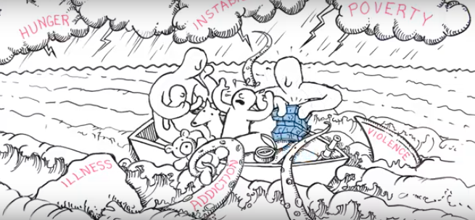
“We build these skills by making connection within and among regions of the brain. Early simple circuits form a foundation that more complex circuits and skills build on as we grow. These connections make our core capabilities possible. The more we use them, the faster they become. The circuits manage incoming information and help us respond with intention–not on impulse.”
“Threatening or stressful circumstances activate other circuits, and trigger automatic responses (flight, fight, freeze). When stresses are constant, these automatic responses become stronger and faster than our intentional responses. For anyone under stress, it’s hard to call on our intentional skills. Under a chaotic environment, it’s even harder!”
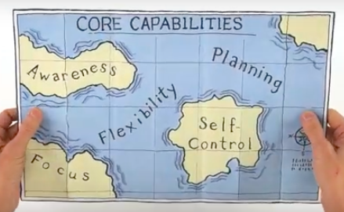
“The key is counterbalancing our automatic responses by building up our intentional ones. How? By redesigning our systems so that they reduce the sources of stress in people’s lives
- Simplify how services are provided
- Help them respond to basic needs
- Build on strengths
“Small successes lead to bigger ones. Core capabilities are built through practice in situations that matter. That’s true for children, adolescents, and adults. When our communities work together to help children and adults build these skills, we create a positive cycle as one generation passes them on to the next. And that helps us all.”

What Are Adult Capabilities?

Planning
Self-Control
Monitoring

Planning & Prioritization

Organization

Time Management

Sustained Attention

Task Initiation

Response Inhibition

Emotional Control

Goal-Directed Persistence

Stress Tolerance

Working Memory

Flexibility

Metacognition
12 Adult Capabilities (aka Executive Skills)

Executive Skills Defined
Planning and Prioritization  Deciding what steps to take. The ability to create a road map to reach a goal or to complete a task. It also involves being able to make decisions about what is important to focus on and what is not. | Task Initiation  Getting started without a delay. The ability to begin projects without undue procrastination, in an efficient or timely fashion. | Stress Tolerance  Managing your stress. The ability to work in stressful situations and to cope with uncertainty, change, and performance demands.
Organization  Knowing where I put things. The ability to create and maintain systems to keep track of information or materials. | Response Inhibition  Seeing the consequence before I say or do something. The capacity to think before you act–this ability to resist the urge to say or do something allows us the time to evaluate a situation and how our behavior might impact it. | Working Memory  Remembering what I did and what I need to do. The ability to hold information in memory while performing complex tasks. It incorporates the ability to draw on past learning or experience to apply to the situation at hand or to project into the future.
Time Management  Know about how long a task will take and what the deadline is. The capacity to estimate how much time one has, how to allocate it, and how to stay within time limits and deadlines. It also involves a sense that time is important. | Emotional Control  Keeping my cool when frustrated. The ability to manage emotions in order to achieve goals, complete tasks, or control and direct behavior. | Metacognition  Evaluating how you’re doing. The ability to step back and take a bird's eye view of yourself in a situation, to observe how you problem-solve. It also includes self-monitoring and self-evaluative skills (e.g., asking yourself "How am I doing?" or "How did I do?")
Sustained Attention  Paying attention, even when I don’t feel like it. The capacity to maintain attention to a situation or task in spite of distractibility, fatigue, or boredom. | Goal-Directed Persistence  Sticking with your goal. The capacity to have a goal, follow through to the completion of that goal, and not be put off or distracted by competing interests. | Flexibility  Going with the flow, accepting change. The ability to revise plans in the face of obstacles, setbacks, new information, or mistakes. It relates to adaptability to changing conditions.

Context Matters: How Living in Poverty Impacts Adult Capabilities
Here are four ways poverty impacts adult capabilities:
- Exposure to high levels of stress in childhood. One of the hallmarks of living in poverty as a child is that it exposes children to high levels of stress caused by not having enough to eat, not having a stable place to live, or being exposed to violence, for example. When children experience too much ongoing stress–commonly referred to as toxic stress–it changes their brain architecture which impairs the development of executive function skills. Impaired skills early on can start a cycle of stress in school that compounds the problem and further limits their ability to access a potentially useful environment or role model. In turn, these compounding impacts can have a lifelong impact on their health and economic outcomes as adults.
- Living under conditions of scarcity—the “bandwidth” tax. Living in poverty often means living without enough resources to make ends meet–under conditions of chronic scarcity–imposes a “bandwidth tax.” This reduces individuals’ capacity to think logically, solve new problems, and process information. It also diminishes their ability to evaluate options to make productive decisions and impairs their self-control, which can cause them to act impulsively.
- Increased exposure to situations that compromise executive functions skills. Living in poverty puts individuals at greater risk of experiencing situational factors that impair their executive function skills. Some situational factors include stress, lack of exercise, lack of sleep, lack of social connections and poor nutrition. In addition, many people may have lacked meaningful relationships with a trusted adult or individual that could model these behaviors for them.
- Added complexity and constant trade-offs related to accomplishing common adult tasks. Limited transportation and childcare options, constantly changing work hours and schedules, unstable pay, and complicated processes for obtaining and maintaining public benefits all require highly developed executive function skills. For example, it takes much greater planning, organization and time management skills if you have to get your kids to daycare and yourself to work via public transportation than via a car.

Adult Capabilities | Real Life Stories – Facilitator answers
Here are 12 stories about how adult capabilities (also known as executive skills) can show up in the day-to-day. For each story, decide on one skill that you see operating strongly.
- Kisha knew her week was going to be busy. She needed to register for school, take her daughter to the doctor, pick up a prescription for her elderly mother and attend a two-day goal-setting workshop. She got out her calendar and mapped out on what day and time she would do each task. (Time Management)
- After looking for a job for three months, John finally found a job working at a busy restaurant with a very demanding boss. He quit after a week because he could not keep up with all the demands placed on him and the added stress was affecting his ability to be a good father to his young children. (Stress Tolerance)
- After months of submitting applications, Merida finally got a job interview. She made a list of everything she needed to do to get to the interview and prioritized it. She immediately called her aunt to ask if she would watch her daughter. (Planning)
- Luke has his heart set on being an airplane mechanic. He took the entrance exam and did not score high enough to get into the program. His case manager suggests that he consider training to be an auto mechanic instead. Luke is disappointed but submits an application to the next auto mechanic training. (Flexibility)
- Marianna has wanted to work in a medical office for as long as she can remember. After her daughter started school, she decided to enroll in a medical coding program. She finds it overwhelming to balance being a parent and a student, but she has decided she’s come too far to give up. She decides she will ask her mother to watch her kids one night a week so she can focus on school. (Goal Directed Persistence)
- Michael was prepped and ready to take the GED test, but when it was time to leave he couldn’t find his ID, which he later found at his mother’s house. He had to wait another month to get on the schedule again. (Organization)
- Evelyn is a hard worker and very conscientious about doing a good job. One day, a fellow co-worker said something she found offensive. Although her initial reaction was to curse at her, she turned and walked away. (Response Inhibition)
- Troi’s case manager told her she could apply for childcare and transportation assistance so she could participate in a short-term training program. She gave Troi the applications and told her where she needed to submit them. When Troi got home, she could not remember where she was supposed to go so she never got the assistance she needed and never enrolled in the training program. (Working Memory)
- Carolyn found looking for a job demoralizing, but in order to keep her benefits, she had to spend at least 20 hours a week looking for a job. She found it especially hard to get started every day, knowing she was going to face many rejections. She decided she would ask a friend she met in her job search workshop to meet at the library so they could work on their job search together. (Task Initiation)
- Devin was frustrated with his boss because near the end of every day, his boss would come to his office and ask him to complete a task that could not be done before quitting time. He scheduled a time to talk with his boss and told him that he was happy to help with tasks that needed to be done but he could not continue to stay late. He suggested that he check in every day at 2 p.m. for tasks that needed to be completed by the end of the day. (Emotional Control)
- Jesse had been attending group job search for two weeks. His goal was to get a job as a security guard. After two weeks, he got bored with the workshops and tired of looking for a job so he stopped going. (Sustained Attention)
- Every Friday in Lynette’s four-week job search class, the instructor asks them to review what they accomplished during the week and to compare it to what they had hoped they would accomplish. She then asks them to adjust their goals or plans for the remainder of the program. (Metacognition)

What Can Counties Do?
Recognizing the toll poverty takes on adult capabilities provides a starting point for redesigning employment and human service programs to achieve better outcomes. There are a number of steps individuals can take to support these skills – and that organizations can take to redesign their approach to service delivery.
- Work to build supportive relationships instead of directive relationships with customers
- Set realistic expectations and make tasks easier by breaking down common tasks into smaller steps and doing some of the tasks with the customer before they leave the office
- Change the environment and modify tasks to reduce the demand on individuals’ executive function skills
- Address issues that impair executive functions such as stress, lack of connections, and lack of exercise
- Create routines that help individuals to set goals and prioritize how to deploy their attentional resources to achieve them
- Work on explicitly building executive skills by providing regular opportunities to train them, challenge them and practice them in the context in which they will be used
- Provide income support and transportation, child care, and housing assistance to help reduce scarcity for customers and the toll poverty takes on individual’s executive function skills

Module Two
Addressing Scarcity

MODULE 2: Addressing Scarcity

BEFORE THE WORKSHOP
One week prior to the workshop:
- Send the attached Listening Guide to your staff electronically.
- Embedded in the guide are links to a podcast they can listen to before the workshop.
A Mind Map is included for taking notes.
Note: We understand that some staff will not have time to listen to the podcast in advance but we strongly recommend that they do. To support this, you may: 1) set up “listening hours” at your office where you have the podcast on for staff to stop in and listen; 2) ask a colleague to lead a lunch break in which staff listen together; 3) send staff the link to their inboxes with an encouragement to take a walk and listen on their headsets. During the workshop, you will review highlights of the podcast and facilitate a discussion around it.

WORKSHOP

Introduction (5 min.)
Explain: Today’s module focuses on scarcity. We can think of scarcity in two ways: (1) Scarcity of capacity – this is a limitation in our skillset and capabilities due to limited time, space and opportunities to develop them growing up (think about module 1); and (2) Scarcity as a limitation in our ability to access our existing skills and capabilities due to external stressors or times of very limited resources. It is important to note that we can also experience both types of scarcity at the same time –leading to exaggerated limitations in performance and critical thinking skills.
This module primarily focuses on the second type of scarcity, which we experience when something we need is in short supply. When we experience scarcity, we tend to focus on what we are lacking and lose sight of things on the periphery. As we will discuss today, “scarcity captures our mind.”

Reflect | An Experience of Scarcity (10 min.)
Guide a short activity through which everyone in the room experiences scarcity.
Here is an example: Do not write down anything during this activity. Use only your working memory. I am going to give you a number to memorize. Try to keep it in your head. Then, we are going to sing a song together and we will see whether you were able to remember the number. The number is 26735164. I will repeat the number twice, then try to keep it in memory while we sing “Twinkle, Twinkle, Little Star” in rounds. Divide the group into four rounds and sing the song. Ask people to see if they remember the number. Do not ask people to report whether they remembered it but simply to reflect on how it felt in their brain to try to do both the number and the song.
Explain that this activity mimics what happens in our brains continually: we tax our “bandwidth” by trying to think about new things while holding onto other things that demand our attention. Note the distinction between someone’s capacity (i.e. your capacity to remember a series of numbers) and access (i.e. your weakened ability to access those numbers at times of stress).
Invite people to privately reflect on their own personal experience as we move through the rest of this workshop.
What kind of scarcity do you experience? How does it affect you?
What do you –or could you – do to keep scarcity from “capturing your mind”?

Explore | Tunnel Vision (30 min.)
Briefly review the two handouts based on the podcast that was distributed before the workshop: Scarcity Overview – In Quotes and Scarcity Stories. Explore:
What did you find most interesting from these stories and quotes?
What are you especially curious about?
As time and technology allow, you may also want to listen to an excerpt from part two and/or an excerpt from part three. Listening in full group can be distracting so we do not recommend that you play any more than short excerpt/s. In small groups, invite everyone to explore some of the questions included in part 2 and 3 of the listening guide. For example, choose 1-2 of the following questions:
- What thoughts do you have about identifying “scarcity traps” in clients or staff?
- How might looking at people through this scarcity lens influence our perspectives?
- How might a scarcity lens influence the types of goals set by clients and the strategies they use to pursue those goals? How might it influence our own goals and strategies?
- How do you see our program better addressing scarcity and the effects of scarcity?

Apply | How Do We Use Our Available Bandwidth? (30 - 45 min.)
To apply the concept to real life, we’ve created realistic scenarios faced by clients and by staff. By working with these scenarios you’ll see how our human brain is continually deciding where to put our attention, and how much “space” to give any one demand. You might also discover how easy it is to run out of bandwidth!
Divide the group into table groups. Put one of our Scarcity Scenarios and a few popsicle sticks (or coffee stirrers) at each table (vary anywhere from 4 – 10 sticks per table). Each table can get the same scenario or different ones.
Explain to each group: You each have a packet on your table with three slips of paper and a set of sticks. For this exercise, each stick represents a piece of our bandwidth. The sticks represent anything that uses your time, energy, resources, etc. We start each day with a finite amount, much like the sticks represented here. Your daily routines take some bandwidth, as do unexpected, problematic, or crisis situations.
As a group, read each portion of the day (starting first with the morning) and decide how many sticks of bandwidth the person uses. Then go on to the next part of the day (do not read ahead!). At the end, see if you have any sticks left, or what tradeoffs you have to make.
Facilitator notes: (1) don’t tell tables up front that they are starting with different #’s of sticks; (2) tell them how much time they have for each part of the day – and let them know when it’s time to move to the next part of the day; and (3) at the end invite the group to reflect on how this exercise illustrates the distinction between a person’s innate capacity vs. their ability to access that capacity in times of stress.
Facilitate a discussion in the full group, hearing from different tables:
What insights did this activity give you about scarcity?
How might you apply these insights to your unique role in our program?

Leave | Addressing Scarcity, and CalWORKs 2.0 (30 min.)
Review the left-hand column of the worksheet: What We Can Do. In trios, generate ideas about what we can do to alleviate scarcity.
In what ways does our program heighten the stresses of scarcity?
In what ways might we alleviate it?
Hear a sample of ideas in the full group. Collect the sheets from all trios to review as follow up to this workshop.
Before closing the workshop, we will focus directly on the CalWORKs 2.0 guides–both of which are designed with an understanding of brain science, specifically this concept of scarcity.

1. Intentional Service Selection (ISS):
ISS, as described in the CalWORKs 2.0 county guide, is built on much of the evidence we explored today:
- Success in work and work-like activities is easier to achieve if customers have their basic needs met and have a voice in deciding the best path forward. Through ISS, workers consider each client’s unique circumstances and goals as a starting point for developing their welfare to work plan. Depending on this starting point, entering directly into work or work-like activities may or may not be realistic.
- Scarcity and bandwidth tax may significantly limit a client’s ability to access their full executive function and self-regulation skills, and worker’s need to keep this in mind when selecting and sequencing activities for clients.
- Counties should also recognize that clients will frequently come to the program and experience relapses during the program into the scarcity tunnel. ISS for counties means designing programs to accommodate potential client slippage and to meet the needs of clients who are in a position of scarcity or maximum bandwidth tax.

2. CalMAP
The CalMAP tool, as presented in the CalWORKs 2.0 frontline guide, is a versatile tool that helps programs operationalize the approach described above.
- CalMAP can be used to assess where the client is right now and determine where/whether someone is hyper-focused on one area, leading to inability to consider other needs. It can broaden someone’s perspective and nudge him or her into thinking at a high level about all areas of their life, rather than focusing on the area, which is most urgently calling their attention.
- CalMAP can also be used to frame a client’s most pressing concerns. By scanning across the life areas, CalMAP can help them to quickly identify where they want to put their attention, and to set a priority goal (wish) for themselves in that area.
What final ideas or questions do you have about scarcity and what it means for our work?
Hear and document all ideas.

RECOMMENDED FOLLOW-UP
About one week after the workshop, send staff a follow-up activity. Here are a few ideas.
- Observe their own “tunneling” and strategies to avoid it. Then, they may meet over lunch once a month as a “scarcity support group” to exchange their insights.
- Watch the instructional video on CalMAP together and talk about how to keep scarcity in mind while using the tool.
- Review any of the recommended resources about brain science available on the next gen website, and reviewed at the end of this module package.
- Join a team to review the worksheets What We Can Do. In this team discuss: How else do you see us (as a program, and as individual staff), keeping the realities of scarcity and tunnel vision in mind as we implement CalWORKs 2.0?

Selected CalWORKs 2.0 Tools/Resources:
ISS Guidelines: Frontline Staff Guide, Section 1 and County Staff Guide Section 2
http://calworksnextgen.org/category/tools/
CalMAP: See next page
There are several additional resources on relevant brain science in the resource library of calworksnextgen.org. A few of these that focus on scarcity are summarized briefly in the resources list attached to these modules.

TUNNEL VISION | Scarcity and How it Shapes Us
From the Hidden Brain Podcast: A Listening Guide
You may listen to the podcast in parts, below, or in full here. The full podcast is 36:40 in length.

PART 1 | A STORY ABOUT SCARCITY
Listen to Part 1. Run time is approximately 06:52.

Overview
Part 1 tells the story of a woman’s experience with one type of scarcity–poverty–and how it led her to make uncharacteristic decisions that worsened her situation.

Questions to Consider After Listening
- Can you think of a time when you have fallen into a scarcity trap?
- How did the scarcity mindset influence your decisions?

PART 2 | SCARCITY: WHAT IT IS + HOW IT SHAPES US
Listen to Part 2. Run time is approximately 12:45.

Overview
Part 2 looks at the many types of scarcity, and how a lack of a basic need re-shapes our thinking, our decisions, and our ability to see the bigger picture.

Questions to Consider After Listening
- What thoughts do you have about identifying “scarcity traps” in clients or staff?
How might looking at people through this scarcity lens influence our perspectives?

PART 3 | HOW TO FREE OURSELVES + OTHERS FROM THE SCARCITY TRAP
Listen to Part 3. Run time is approximately 15:06.

Overview
Part 3 tells the story of a woman’s experience with scarcity of time, and how she was able to step back and manage the effects of scarcity. This part also discusses ways that we can reframe our perceptions of those who experience scarcity in order to address their situation more effectively.

Questions to Consider After Listening
- How might using a scarcity lens influence the types of goals set by clients or staff, and the strategies they use to pursue those goals?
- How do you see programs could better address scarcity and the effects if scarcity on clients or staff?

A Mind Map
As you listen, you may find it helpful to jot down reactions and questions that arise for you.
TUNNEL VISION
Scarcity and How
it Shapes Us
General Thoughts + Curiosities
PART 3 | How to Free Ourselves
PART 2 | What it is + How it Shapes Us
PART 1 | A Story About Scarcity

A Scarcity Overview - In Quotes

SCARCITY EXPLAINED
“Not having enough of what you need can become the only thing that matters to you. When you feel that something important is missing in your life, your brain starts to focus on that missing thing.”
“When we are busy juggling a resource –worrying “should I pay for dinner and, if so, will I have money for the kids’ school trip?” It taxes our bandwidth. It’s like trying to hold an eight-digit number in our head all the time.”

EFFECTS OF SCARCITY
“When you have scarcity, it creates a …mindset that leads to… behaviors which, in the short term, help you to manage scarcity – but in the long term only make matters worse.”
“Scarcity is a trap. Scarcity today can beget behaviors that lead to more scarcity tomorrow.”
“It’s not that poor people focus on the short term because that’s all they want to think about; it’s often all they can think about.”

SOME IMPLICATIONS
“This lens offers a new way of thinking. What if it is not that poor people are somehow deficient but that poverty … changes our minds?
“To manage scarcity, …recognize when you’re trying to do something to address your scarcity–and when you want to focus on something, and not let it intrude. Avoid tunnel vision. Be present.
Watch how we confound efforts to help the poor with efforts to educate them. Create “fault tolerant” programs so that when people in poverty make mistakes, respond as we would to airline pilots: alert them of the mistake and diminish the consequences.

Scarcity Stories


BRANDY | SCARCITY OF MONEY
Brandy worked for a company for over a decade. One day, in a rush to pick up her baby she accidentally used her company card to purchase diapers-she was terminated. Without Brandy’s income, her marriage was strained and she left her spouse. Without steady employment, her household supplies dwindled. Brandy ordered a new credit card to make ends meet, and stocked up immediately on supplies, maxing out the card. She forgot to factor in costs for gas and the credit card bill itself–soon, she was trapped by debt. In retrospect, she can see her mistake in not budgeting for the whole month, but in the moment it was either “pay the bills” or “feed the kids.”


MINNESOTA HUNGER STUDY | SCARCITY OF FOOD
During WWII, aid workers needed guidance on how to bring people back from the brink of starvation. Researchers at the University of Minnesota launched a yearlong experiment on hunger. Thirty-six young men went on a starvation diet –the effects on their bodies were clear, but it affected their minds as well. The subjects’ conversations were fixated on food–they planned to open restaurants and memorized recipes. In the absence of food, they could not focus on anything else.

SUGARCANE FARMERS | SCARCITY OF MONEY
Sugarcane farmers in India are paid only once per year. In the months after a harvest they are well off, but by the end of the harvest cycle they are relatively poor. Researchers tested the farmers on their long-term thinking at both points, and found that post-harvest they had strong impulse control and thought long-term. The same farmers at the end of the harvest cycle were focused on how to make it to the next week.

KATY | SCARCITY OF TIME
Katy is a driven person. She graduated top of her class in medical school, but when she started her residency her new schedule was grueling. In her free time, Katy became fixated on exercise, and gradually her home-life fell apart–she had no groceries, a messy home, and forgot to pay a bill. Katy previously battled anorexia–when she was trapped in this scarcity tunnel, old habits returned. Katy only realized the path she was on when it started impacting her work–the final straw was when she almost forgot to order insulin for a diabetic patient. She entered a residential treatment center and finally emerged from the tunnel. Katy started scheduling time to do “nothing” and this freed up bandwidth and allowed her to enjoy her work and perform better.

Scarcity Scenarios | For Small Groups

Scarcity Scenario 1: Sick Child, and More….
Morning: You get up in the morning to a sick child. After going through your normal routine to get ready for work (which you cannot miss), you have to call babysitters to see if someone can come over on short notice, which you will pay more for.
Someone is able to come, but you are already running late for work and traffic is bad. You feel bad leaving your sick child, but if you miss work you might lose your job.
Afternoon: You have been busy with customers all day at work and have not had time to check in with the babysitter. Your boss was mad that you were a few minutes late. He tells you that if you leave to meet with your case manager, like you planned, your pay will be docked (and that babysitter cost a lot more than you have). You decide not to go, putting your government benefits at risk.
Evening: On your way home you remember that your child needs medicine picked up from the pharmacy, so you have to turn around. You get home and realize there is nothing for dinner, so you take your child with you to the store, even though you are both exhausted. Now that you missed your meeting, you are constantly worrying about what will happen with your benefits and whether you’ll be able to reschedule your meeting.

Scarcity Scenario 2: Clocking in Late, and More….
Morning: You wake up, get the kids ready for school, drop them off at the bus stop, get ready for work, and make it out of your apartment with just enough time to make it to your work placement. On your way, you get a flat tire and have to wait for the bus, which is late (as always). You get written up for clocking in to your shift late.
Afternoon: Because of your hectic morning, you have felt anxious and depressed all day. You feel like juggling work and kids is too hard and cannot see how you will keep doing it, but you need money to fix your flat tire and get school supplies for the kids. You call your therapist for support but she is not in the office. Your boss asks if you can come in early the next day and you say yes, fearing what will happen if you decline.
Evening: You pick the kids up and are trying to help them do their homework when you notice something slipped under the door. It is a notice from the water company that you have five days to pay your past due balance or your water will be cut off. Now you know you have to keep going to work, even though it is getting harder every day. A reminder pops up on your phone that you need to meet with your case worker tomorrow morning, but you already told your boss you would come in to work early.

Scarcity Scenario 3: Needing an Apartment, and More….
Morning: You and your children have been living with your sister since moving out of your boyfriend’s apartment. You are scheduled to go into work at 9 a.m., after getting the kids ready and taking them to school and daycare. However, at 8 a.m., your case manager calls and tells you an apartment is open to view but only if you can go this morning at 10 a.m. You do not want to miss work, but you also really need to find a place to move.
Afternoon: You decided to go into work instead of going to see the apartment since you did not want to risk losing your job. Now all you can think about is the chance you have missed out on and you feel distracted at work, causing you to give poor customer service, which your supervisor mentions.
Evening: As soon as you get off work you pick the kids up from after-school and take them home to do their homework and get dinner started. Your sister comes home and you tell her about the apartment you did not go see. She gets mad and tells you that you need to get serious about moving and gives you 30 days to find a place or you can’t stay with her.

Scarcity Scenario 4: Traffic, and more….
Morning: You wake up, get ready for work, get the kids ready for school, and start to leave the house. You are getting ready to go into your job as a case manager when your phone pops up with a calendar alert and you realize you have two clients scheduled for the same time, as soon as you get into the office. After making your way through traffic, you arrive to find both clients agitated. You explain your mistake, but both want to see you immediately and neither will reschedule.
Afternoon: Between your scheduling mix-up and a team meeting that went late, you did not have time for lunch and are feeling stressed out. Your daughter’s school calls and says she got in trouble and needs to be picked up early. You cannot leave work, so you have to call a friend to get your daughter and plan on talking more to her about this when you get home. You also have to meet with a co-worker to do a peer evaluation today and are anxious because you have a lot of constructive feedback to give.
Evening: When you finally make it home, your daughter will not talk to you about what happened at school and your son tells you he has a project due for school tomorrow that he has not started yet. You do not want to reward his procrastination, but you are exhausted so you end up doing most of the work for him just to make sure it gets done. You do not get to bed until much later than planned and will only get a few hours of sleep before starting all over again.

What We Can Do
Your program can help alleviate as well as unknowingly contribute to scarcity experienced by families that you serve.
Examine the sample experiences below. Choose 3 that you see often. Think creatively about how your program–or you personally–might take steps to help customers who are experiencing these kinds of scarcity of time and resources. Remember, as always, to focus on maximizing the innate strengths and resourcefulness of these families.
Think about families you serve and name one challenging experience that was not included in our list of sample experiences. Jot down your ideas about how you–or your program–might respond.

Experiences that Contribute to Scarcity of Time and Resources | What We Could Do–or Do More (Jot down your ideas in this column)
Limited transportation options

Limited and low-quality child care options

Endless search for affordable housing

One parent doing the job of two

Constantly changing work hours and schedules

Competing demands for limited time: work, parenting, program requirements

Inflexible appointment times and requirements

Long waits in public offices

Paperwork, paperwork, and more paperwork

One challenging experience not listed above: | What we could do – or do more of:

Module Three
Coaching in Client Interactions

Module 3: coaching in client interactions

BEFORE THE WORKSHOP
One week before the workshop, send the attached Module 3 Viewer’s Guide to your staff with a link to a 17-minute video they can watch beforehand.

WORKSHOP

Introduction (5 min.)
Explain: Today’s workshop focuses on using coaching strategies during all different types of client interactions. The three components of coaching we will address today are (1) strengths-based approach, (2) trauma-informed care, and (3) motivational interviewing. In today’s workshop, we will look at these coaching strategies and explore how we can use them to strengthen our interactions with clients.

Reflect | How you Already use Coaching Methods (10 min.)
Explain: Coaching is defined as “partnering with clients in a thought-provoking and creative process that inspires them to maximize their personal and professional potential.” In the human services world, coaching supports clients in building the skills and mindsets they need to take on the complex task of moving out of poverty. Under traditional case management clients are typically not able to build these skills and mindsets because the worker often simply identifies and solves problems for the client, and the client tends to take a more passive role. The relatively new approaches of motivational interviewing, trauma-informed care, and strengths-based practices can strengthen staff’s abilities to work more collaboratively with a client, respect the client’s autonomy and perspective, and keep the client’s best interest in mind.
Explain: Coaching relies on a few key principles:
People have their own answers. More than just seeing strengths or the best in people, coaching encourages a view that adults are the experts on their own situation. They are capable, creative, can find their own answers, and can recover and learn within an equal relationship with their coach.
People have the potential for growth and learning (as opposed to a belief that they are who they are). Coaching helps clients believe they can, in fact, improve things like problem solving and goal attainment through practice. Coaching addresses barriers but barriers are not the focus. Coaching provides a safe atmosphere in which clients can take new risks. Coaches build trust and rapport.
People need different things at different times. Coaching provides a flexible lens to address the changing needs and particular definition of success for each family.
Explain that we may be using some of the coaching methods already. With the entire group, read the coaching methods listed in the handout. As you do, pause after each coaching method and ask participants to write down a time when they saw this method in action or used it themselves. They should also write down the result of using that method.

Explore | Strengths-Based Approach, Trauma-Informed Care, and Motivational Interviewing (50 min.)
Explain: We will start by talking about a strengths-based approach, which means that staff members focus on and build on a client’s strengths. There are three main components of this approach:
- Actively explore each client’s strengths
- Acknowledge and validate the client’s strengths and resources
- Encourage the client to lead the conversation and decision-making process
When reviewing something that happened in the past, especially some misstep or something that did not go well, try to focus on the person’s strengths to help them move forward. It is okay to acknowledge the things that did not work, did not go well, or were bad, but always do so in conjunction with focusing on growth by building up, drawing out, and channeling what the person is strong or good at.
Using the examples in the handout, describe what a strengths-based approach looks like when interacting with clients, and then describe how such an approach is different than a traditional deficit approach.
Take a moment to talk about barrier removal in a strengths-based approach. Remind staff that referrals to barrier removal services are still an important part of CalWORKs, especially when the client is facing a crisis. However, under the new approach, workers should spend much more time than in the past collaborating with clients to help identify and build on their strengths. Especially once initial barriers are addressed and the client is starting welfare-to-work activities, it is important to continually identify and affirm a client’s strengths.
Next, ask participants to write down some of their strengths in the space provided. They should try to write down at least one personal strength (for example, cooking) and one professional strength (for example, leading meetings).
When they are done, go around the table and ask them to share their strengths with others. If the attendees know each other, encourage them to affirm each other’s strengths.
Explain: Next, we’re going to talk about trauma-informed care, a strengths-based approach grounded in an understanding of and responsiveness to the impact of trauma in a person’s life. Trauma-informed care is a universal design for serving trauma survivors, provided to all people by all staff. Applying this approach in the CalWORKs setting means considering the physical, psychological, and emotional safety of both staff and clients, and creating opportunities for clients to rebuild a sense of control and empowerment.
As a group, talk through each section of the trauma-informed care handout. What sticks out for you? How is this different from the approach you typically use?
Explain: Next, let’s talk about motivational interviewing (MI), a way of structuring conversations to help clients address ambivalence toward change. MI techniques aim to strengthen clients’ motivation or commitment to set and achieve their own goals. Through collaborative conversations, the MI approach allows coaches to guide clients through an exploration of their reasons for change. In doing so, clients can make their own argument for why it is important for them to make a change or accomplish a goal.
MI is based on the idea that people often have competing drives in life. For example, one may have a sincere desire to lose weight but also continually choose to sleep in rather than go to the gym. Using MI techniques, coaches learn to narrow the gap between a client’s goals and motivations (losing weight) and the changes in behavior needed to accomplish those goals (waking up and going to the gym). With MI, coaches tap into preexisting reasons for change that a client already possesses. In this example, perhaps the client wants to lose weight so that they can play with their children more often.
In another example, a client has repeatedly mentioned wanting to get a GED, but hasn’t spent any time studying. A worker can point out this gap between desire and behavior, and help the client identify the underlying reasons why they want to get a GED. Perhaps the client wants to become a nurse and needs a GED to get into a nursing assistant training program. The worker can encourage the client to think about working as a nurse when faced with the choice of whether or not the study. We are all more likely to follow through with an intermediate task when we remind ourselves how much we care about our ultimate goal.
In the full group, review the handout on motivational interviewing, talking through each section. When reviewing the portion on what to say to clients, pause after each statement and ask participants to write an example of that type of question or statement. Then invite individual or small group reflection:
Given your role in the program, how do you think you can use motivational interviewing in your everyday practice?

Apply | How Coaching Looks in Different Client Interactions (30 min.)
In the front of the room, the facilitator should model coaching during an interaction with a participant. The facilitator should start by asking what is important to the participant and then slowly draw out and explore something the participant would like to change in her or his life. The participants can either respond as themselves or role play as a client.
In pairs, step through the Client Biography handout. After completing the work in pairs, the pairs should share their takeaways with others at their table.

Leave | What We Can Do in CalWORKs 2.0 (30 min.)
Explain: The three coaching strategies can be applied to the typical CalWORKs case flow in many ways. Here are some examples:
- During administration of the OCAT and assessment, staff can use trauma-informed care approaches to help the clients feel safe when discussing difficult topics. When possible, frame questions to clients in a way that allows them to disclose only the details they choose. Do not force clients to rehash traumatic details if they do not want to do so.
- Staff might start by using motivational interviewing to learn more about the client and what they are passionate about or use it when they sense that the client is ambivalent or uncommitted to a proposed change. MI also gives an opportunity to invite clients to guide the discussion and identify specific ways in which the staff member can serve them best.
- During ongoing check-ins, staff can continually encourage clients to notice their developing and expanding strengths. When reviewing and revising a goal, focus on the strengths of the client and ask questions that encourage self-reflection about strengths. It can be motivating for clients to reflect on the progress they have made.
In small groups, discuss how your program could deploy the coaching strategies we have discussed. Reflect on the different types of interactions you have with clients. Acknowledge what you are doing well in these areas and where you might improve. Then exchange ideas for goals that feel meaningful and practical (challenging but within your reach).
For each of the three coaching strategies (strengths-based approach, trauma-informed care, motivational interviewing), consider these questions:
How does our program already use this coaching strategy to support clients?
What more could we do?
What would I personally like to try in my interactions with clients?
Each small group should report back to the full group:
What is one concrete idea or goal you’d like to pursue as an individual or as a group to adopt a more coaching-based approach in your program?
Close the workshop by hearing―and documenting―as many ideas as possible.

RECOMMENDED FOLLOW-UP
One week after the workshop, send around the “Strengths-Based Approach” handout. Ask staff to consider the following questions as they meet with clients:
What is showing up as a strength, and how might that serve him/her better?
What is showing up as a possible weakness, and how might I/we provide support?
At a subsequent meeting with county staff, consider opening up the floor for examples and generate a discussion about ways to build on clients’ strengths and support clients in dealing with their weaknesses.

Module 3 Viewing Guide: A Motivational Interviewing Resource Video Viewing Guide
Watch this video alone or with colleagues. As you watch, use the prompts below to reflect.
Write your notes about the video below.

What information in the video surprised you?

After viewing the video, write below about a time that you struggled to change something you wanted to change. Include your thoughts and feelings at that time.

Coaching Methods
Even if we do not use these terms, most of us have past experience in using these methods in conversations with our friends, family members, or clients. For each method, write down a time when you saw this method in action or used it yourself. Write down the result.
Method | Time when you saw this method in action or used it yourself | What was the result?
Asking powerful questions
Open-ended questions evoke clarity, action, discovery, and insight.

Holding the client’s agenda
The goal is to follow the client without knowing the right answer, giving solutions, or telling the client what to do.

Visioning
Create a strong mental image that inspires action and creates a picture for the client's future life.

Active listening
Listen for the client’s vision, values, and purpose as expressed by words and demeanor.

Clearing
Allow the person to vent or clear a situation that might be interfering with his or her ability to be present without showing judgment or attachment.

Bottom-lining
Get to the essence of the communication, rather than engaging in long descriptive stories.

Referring
Make a referral for issues that therapy or services from another organization might be better able to address.

Strengths-Based Approach
Key components of a strengths-based approach:
- Actively explore each client’s strengths
- Acknowledge and validate the client’s strengths and resources
- Encourage the client to lead the conversation and decision-making process
What does this approach look like in practice?
Questions to ask the client as you are getting to know him or her (first meeting): | Questions to ask when you are checking in with the client (future meetings):
Tell me about something you are really proud of.  What’s something you are particularly good at?  What do you like to do for fun?  What are the things in your life you really value?  What does a good day look like for you? | What are you doing/managing well?  What are you feeling good about?  What strategies, tools, resources, or supports are working for you right now?  What have you learned so far that can help you moving forward?  How can we build on where you are now?  What one thing could you do to take a step in the right direction?

What’s different about a strengths-based approach?
 | Deficit/problems-based approach | Strengths-based approach
Roles | Conversation led by staff  Staff are the experts and can help fix the problem  Clients are passive receivers of services | Client and staff collaborate during meetings  Clients are the experts and can solve their problems (perhaps with some support)  Staff empower clients to identify solutions
Focus | Problem and past oriented | Goal and future oriented
Key questions | What is the problem?  What is wrong?  What does the client need? | What resources, knowledge, and skills does the client have?  How can we build on existing strengths to move forward?  What could the future look like, or how could the client’s life be different (for the better)?

In this space, write down some of your strengths. Write down at least one personal strength and one professional strength.

When everyone at your table is done, go around the table and share your strengths with others.

Trauma-Informed Care
Trauma Defined
Individual trauma results from an event, series of events, or set of circumstances that the person experiences as physically or emotionally harmful or life threatening, and that has lasting adverse effects on the individual’s functioning and mental, physical, social, emotional, or spiritual well-being. The following are some examples of trauma:
- Experiencing or observing physical, sexual, and emotional abuse
- Childhood neglect
- Having a family member with a mental health or substance use disorder
- Experiencing or witnessing violence in the community or while serving in the military
- Poverty and systemic discrimination, including racial discrimination
The spirit of trauma-informed care
Trauma-informed approaches to care shift the focus from “What’s wrong with you?” to “What happened to you?” by focusing on the following:
Understanding trauma: Appreciating that many problem behaviors began as understandable attempts to cope with past traumatic experiences
Promoting safety: Establishing a safe physical and emotional environment for clients and staff, which includes using language that is neutral, objective, and always avoids shaming
Supporting client control, choice, and autonomy: Giving clients maximum choices and control over the process to help them regain a sense of control over their daily lives
Sharing power and governance: Sharing power and decision making across all levels of an organization
Ensuring cultural competence: Understanding each client in the context of his or her life experiences and cultural background, and seeking growth opportunities specific to cultural backgrounds
Integrating care: Maintaining a holistic view of clients that acknowledges the interrelated nature of emotional, physical, relational, and spiritual health
Promoting healing in relationships: Believing that establishing safe, authentic, and positive relationships can be corrective and restorative to trauma survivors
Understanding that recovery is possible: Understanding that recovery is possible for everyone, regardless of how vulnerable he or she may appear
Core skills in trauma-informed care
The following practices reflect the principles of a trauma-informed approach:
- Use individuals’ strengths to empower them as you help develop their plans and activities.
- Inform clients of their choices regarding activities so they can choose the options they prefer.
- Maximize collaboration among staff, clients, and their families in goal setting, planning, and doing.
- Create office settings and activities that ensure clients’ physical and emotional safety.
- Promote trustworthiness by creating clear expectations with clients about their options and activities.

Motivational Interviewing
The following are the four guiding principles of MI:
- Express empathy: Coaches must attempt to see the world through the eyes of the client by asking themselves, “How might I feel or act in this situation?”
- Develop discrepancy: Coaches should notice and point out “gaps” between what clients say they want and their behavior(s).
- Roll with resistance: Rather than reciprocating, calling out a client’s resistance, or using a confrontational tone, coaches should invite (not impose) new perspectives.
- Support self-efficacy: Coaches should encourage clients to focus on their ability to control their own behavior and events that affect their lives.
What this approach looks like in a meeting:
Step 1: Engage. Using a client-centered approach, strive to fully understand the situation from the client’s perspective without having a preconceived agenda.
Step 2: Focus. Guide the client toward a change that is important to them (setting a meaningful goal).
Step 3: Evoke. Draw out the client’s intrinsic motivation (reasons/importance for change) and her/his own ideas for change.
Step 4: Plan. Create a “bridge” to change by reinforcing commitment language and assisting the client with creating a plan for change.
Step 5: Follow-up. In future interactions with the client, ask about his or her progress towards change. If the client made progress, celebrate the progress. If needed, loop back to previous techniques to point out any gaps in clients’ desires and behaviors.
What to say to clients:
- Open-ended questions cannot be answered with a single word. Asking open-ended questions invites collaboration and deeper thinking around an issue.
  - Example:_____________________________________________________________
- Affirmations are statements that highlight a person’s resources, such as a specific trait, attribute, or strength.
  - Example:______________________________________________________________
- Reflective listening involves stating back to the client what he/she said in an accurate, empathetic way.
  - Example:______________________________________________________________
- Summarizing involves collecting and summarizing statements from parts of the conversation to clarify and confirm the client’s views.
  - Example:______________________________________________________________

Client Biography
Divide into pairs. Read this brief bio about a CalWORKs client:
Drew is a single father who does not have a high school diploma and currently is unemployed. He has faced bouts of homelessness in the past; however, for the last six months has been able to secure housing for himself and his 6-year-old son. He is confused about where to start but knows that he cannot make it unless he has some help.
Imagine it is your first meeting with Drew. Remembering what we have talked about so far, what would you say to Drew?

Review what you wrote down. How well are your ideas aligned with a strengths-based approach? How well aligned are they with a trauma-informed care approach? How do your ideas line up with the guiding principles of motivational interviewing? Make changes to align your ideas more closely with these three concepts.
Now, do a quick role-play activity. One person will be the client and one will be the frontline worker.
Maria lives in an apartment with her two school-age kids. She does not want to talk about her children’s father; he is not in their lives. Maria has a high school diploma but is unemployed. She is very connected to her extended family and enjoys cooking for them. Maria is content with her life and does not seem particularly motivated to make a change.
After the role play, reflect on what went well and what could have gone better. Share these takeaways with others at your table.

Module Four
The Art and Science of Goal Achievement

MODULE 4: The Art and Science of Goal Achievement

BEFORE THE WORKSHOP
One week prior to the workshop, send participants the worksheet The Art and Science of Goal Achievement.

WORKSHOP

Introduction (5 min.)
This workshop is about goal achievement. As the title suggests, we will look at the art of it all (what do you do to successfully identify and pursue your goals and to guide others to successfully identify and pursue theirs?). We will also look at the science of goal achievement (what does research suggest about how to successfully set and achieve goals?). Then, we will put it all together. Over the last week, we invited you to pay special attention to the goals you have successfully achieved because we want you to bring your own experience to today’s conversation.

Reflect | What Our Experience Has Shown Us (30 min.)
Acknowledge: We all successfully set and achieved goals in our lives. Researchers have now provided us with many valuable insights into goal achievement–these insights may echo your own.
Think back to a goal you recently set for yourself and achieved. Take a silent moment and jot down all the factors that helped you to be successful in achieving that goal. Get up out of your seats and partner with someone you don’t know or talk with very much. In your pairs, each share: What helped you to achieve a goal?
After five minutes, rotate to a new person and repeat the exchange.
When everyone is seated, ask the group to call out some of the personal things that have helped them achieve their goals. Capture these on flipchart paper titled “Success Strategies” so you can refer back to them shortly. You may want to reflect briefly on what was named such as the difference between internal and external factors for success.

Explore | What the Research Has Shown Us (20 min.)
Together, take a look at the handout Goal Achievement Framework: GPDR/R. Notice how the four questions in the preparatory activity parallel the parts of the framework.
Explain: Goal, Plan, Do, Review, and Revise (GPDR/R) is a four-step goal achievement framework that, if practiced regularly and with fidelity, will build adult capabilities and make setting and achieving goals easier–and more effective.
[Note: These capabilities are explored more deeply in a companion module. Depending on whether these staff did that module recently, you may want to provide a brief reminder of those skills. In short, these skills are ones we use and need for everyday tasks that rely on planning, self-control, and monitoring skills. The connection is illustrated in Executive Skills and Goal Achievement.]
The four steps of GPDR/R always happen in the same order. Each step builds on the last and leads to the next. Together, they form one comprehensive adaptable four-step framework. It works best when used in its entirety, again and again: set a goal, craft a detailed plan, put the plan into action, review progress and revise.
Use the handout The Path to Goal Achievement to highlight what the evidence suggests is important in each part of the framework. This deceptively simple framework actually captures a whole set of complex steps that require a fair amount of intentionality (the science) and a good dose of creativity (the art).
In small groups, consider the success strategies we named at the beginning of the workshop (posted on the walls): Where do you see your success strategies “fitting” within the goal achievement framework?

Apply | GPDR/R (40 min.)
Individually, think of a goal that you want to achieve by the end of the weekend. Make sure it is meaningful to you and challenging, but within your reach. Use the GPDR/R form to write down your goal and think about why it is important to you. Then, imagine what it would feel like to achieve your goal. Next, draft a plan for getting to the goal. Write down as much detail as you can about your plan. Imagine yourself doing the plan. Now, consider what might get in the way of your being successful and come up with some strategies you can use to overcome those obstacles. Consider the questions on the form and write down your thoughts.
We will now take this process off the paper (the science) and walk through it with a few of you (the art). We will all be supportive and we will honor the confidentiality that comes with sharing this space together today.
Who wants to volunteer to share their goal, and think through a plan for getting there by the end of the weekend?
One facilitator will model the process of guiding someone through the GPD parts of the framework. While facilitating the process, it is important that you walk the person through each step. At the end, you want the person to have:
(1) set a goal they care about and can achieve,
(2) imagined what it will feel like to achieve the goal;
(3) identified the steps they will take to achieve the goal in great detail;
(4) thought about what might get in the way and developed solutions to the obstacles to successfully achieving the goal; and
(5) developed a detailed plan including how long it will take, when they will do it, how they will use transportation, and their strategies for staying on track.
Invite others to use the handout Language of Goal Achievement as they observe. Afterward, we’ll see how applying this language may have supported the process.
As time allows, repeat with another volunteer (and/or invite the group to name one volunteer and one guide at each table to practice the process while others observe).
After the demonstrations, ask:
What was useful in this framework for the guide / coach?
What was useful in this framework for the person with the goal?
How did this process differ from your usual interactions with participants?
What questions do people have about using this framework to walk through goal achievement?

Leave | Supporting Goal Achievement in CalWORKs 2.0 (25 min)
CalWORKs 2.0 has a number of tools that can work in different ways, and synergistically, to support the goal achievement framework. For all of these tools: (1) there is lots of room for individual style and flexibility in using this framework; and (2) the tool is meant to support the process (but is never more important than the process).
In small groups, discuss what implementing a GPDR/R process with your clients would look like.
- How are you already working with clients to set goals?
- How are you already working with clients to achieve goals?
- In what sorts of meetings or settings with clients could you bring up goal-setting?
- How can you help clients make effective plans?
- How can you help a client “do” their goal in between meetings?
- What seems hard about implementing a GPDR/R process with clients?
- What questions do you have?
As time permits, review answers to these questions in the full group.

RECOMMENDED FOLLOW-UP
- Experiment, personally, with GPDR/R by using it yourself for one week and/or by using it to guide a friend or colleague through the goal achievement process. Bring your insights to our next workshop.
For management staff: Use the guidance provided in Introduction to County Goal-Setting to work in teams to set county goals. Create a plan through which staff will periodically reflect on the goals, as well as how the team is progressing toward those goals. Revise your plans as you go.

CALWORKS 2.0 TOOLS/RESOURCES

Frontline Guide
- Suggested Tools for Different Customer Interactions | Frontline Guide
My Goal-Plan-Do-Review | Frontline Guide

County Guide
- Intentional Service Selection: The Right Services for the Right Clients | County Guide
Introduction to County Goal-Setting | County Guide
There are also many relevant resources to explore in the resource library of the CalWORKs next gen website.

The Art and Science of Goal Achievement: Preparation
We, as well as CalWORKs participants, set and achieve goals all the time. We learn how to do this from a young age – through observation, experience, and positive reinforcement. Usually we set and achieve goals without paying attention to all the many steps in the process. This week, we invite you to be a bit more mindful of the natural process you follow so that we can draw on that personal experience when looking at the art and science of goal achievement together. Try to think back to when you struggled with this process, and recall just how long it took you to develop and consistently apply these skills.
Pay special attention to your goals (your wishes, aims, desires)–the things you envision achieving for yourself this week. Jot down responses to the following questions and bring it to the workshop with you. It is private but will be a useful reference.
ONE:
What is one goal you set for yourself this week?

TWO:
What was your plan for how you would achieve the goal? Did you write it down? Set any reminders? Share it with anyone?

THREE:
How did you do? What, if anything, got you off track? What did you find helpful to keep you on track?

FOUR:
What did you discover about your goal, or yourself, along the way?

FIVE:
What’s next?

Goal, Plan, Do, Review, and Revise:
An Executive-Function Informed Goal Achievement Framework

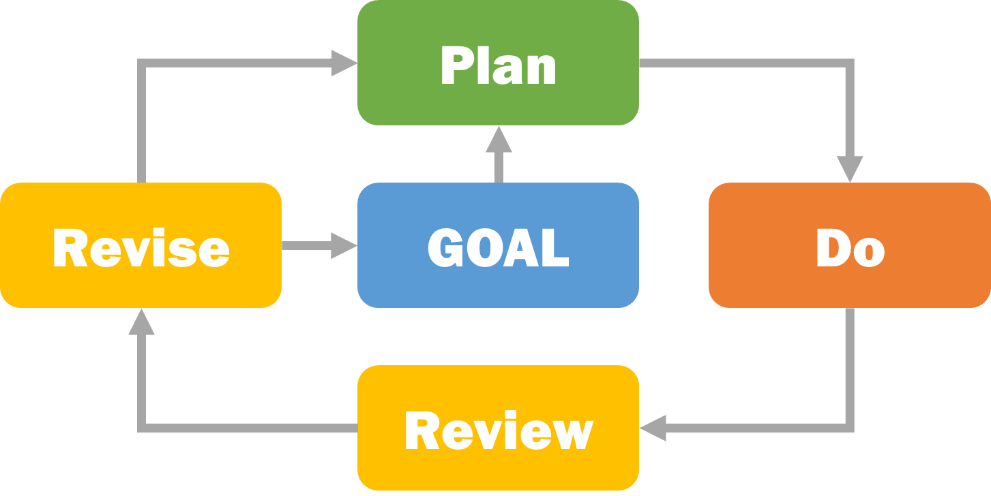

Step #1: Set a Goal – something you want to accomplish

Step #2: Develop a Plan for how to get from here to there

Step #3: Do the Plan – put it into action

Step #4a: Review and assess your progress

Step #4b: Revise – take the next step, make a new plan, or set a new goal

Executive Skills and Goal Achievement
Goal | Metacognition, working memory
Plan | Planning/prioritization, organization, time management, working memory
Do | Task initiation, response inhibition, time management, sustained attention, working memory, flexibility, organization, goal-directed persistence, stress tolerance, emotional control
Review/  Revise | Metacognition, working memory, and flexibility

- Goal: We use working memory to remember experiences and metacognition to evaluate those experiences. That is what helps us come up with meaningful goals – we avoid things that we do not like and do more of what motivates us to move forward.
- Plan: Our planning and prioritization skills help us break goals into the small steps. We use organization skills to gather resources we need to complete a task and to keep them in a place where we can find them. We use time management skills to help estimate how long a task will take and decide when we will do it. We draw on working memory to identify what else we need to do and to remember the steps so we can prioritize them.
- Do: Executing a plan draws on many executive function skills, but mostly involves practicing self-control to direct our behavior in a purposeful way. Task initiation allows us to get started (remember, success is starting). Time management allows us to wisely use time we have available. Response inhibition allows us to avoid distractions and stay focused. Sustained attention helps us stick with a task until it is complete. Goal-directed persistence helps us to complete each step along the way and to stick with the goal even when the going gets rough. Stress management helps us stay calm when we face competing demands and aids us in proactively identifying ways to reduce stressors. Emotional control helps us keep emotions in check, and cognitive flexibility allows us to problem-solve around potholes (obstacles).
- Review & Revise: When reviewing our progress towards a goal, we are once again draw on working memory and metacognition skills which help us remember what we did (or didn’t do) and why. Then we can assess what did and did not work. Cognitive flexibility allows us to abandon goals that are too hard or no longer meaningful and come up with new goals. We may also find that a plan is in order if the previous one did not produce the results we wanted.

The Path to Goal Achievement: Goal, Plan, Do, Review, and Revise

Step #1: Set a Goal – something you want to accomplish
- Set a goal that is:
  - something you truly care about
  - challenging but within your reach
- Your chances of being successful increase when you:
  - imagine how you would feel if you accomplished your goal
  - write it down and post it in a prominent place

Step #2: Develop a Plan for how to get from here to there
- Characteristics of a good plan:
  - Specific, with the steps you need to take, the resources you need to complete them, and the details of where and when you’ll complete the steps clearly laid out
  - Identifies obstacles and solutions for addressing them
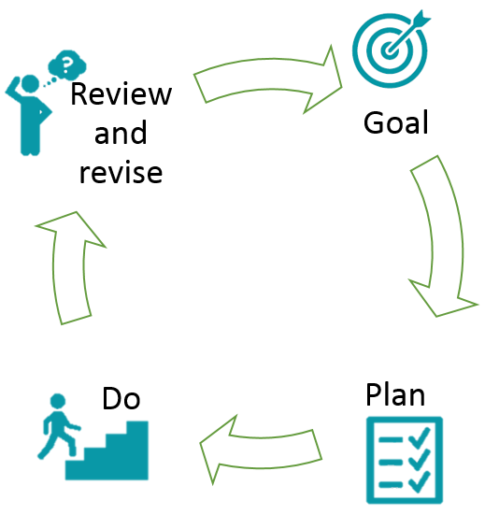
  - Written down

Step #3: Do the Plan – put it into action
- To successfully complete a plan:
- Stay focused; follow the plan
- Remember what you need to do when
- Manage your time and stay organized
- Manage your stress
- Ask for help when you need it
- Stick with it until it is done

Step #4a: Review and assess your progress
- What worked well?
- What got in the way? How did I respond?
- Did I follow my plan?
- What steps remain?
- What do I need to do next?

Step #4b: Revise – take the next action steps, make a new plan, or set a new goal
- Look back, move forward
- Recognize change as a regular part of the goal achievement process
- Embrace change as a learning opportunity

The Language of Goal Achievement
A critical part of supporting people through the GPDR/R framework is changing how we talk about goals, plans, and next steps. The following are some prompts you can use to help facilitate a goal-achievement conversation:
GOAL
- What are your hopes and dreams for the future?
- What is something meaningful to you that you want to achieve? Is it within your control?
- What matters deeply to you that you could see yourself working towards in the next month?
- What keeps you motivated even when things get hard?
PLAN
- Let’s work backward and think about what steps you need to take to get where you want to go. What resources you will need?
- Let’s map out an action plan for the next week. When will you do each step, how long do you think it will take, where will you do it?
- What might get in the way? What can you do if that happens?

DO
- Let’s create a reminder system to help you put your plan into action.
- How can we support you as you move to the next step in your plan?
- It can be hard to do this alone—who might be able to help you with your next steps?
- Let’s try doing the first part of your plan together. I’m here to help if you get stuck.
REVIEW
- How did things go this week? What went according to plan?
- What got in your way? How did you respond?
- What could you have done differently?
- What did you learn about yourself?

REVISE
- Does your goal still feel like the right goal? It is achievable?
- What would you like to do next?
- What would help you to move forward?
- How can I support you in coming up with a new plan or goal?

Module Five
Coaching With the Calworks 2.0 tools

MODULE 5: coaching With the CalWORKs 2.0 Tools

BEFORE THE WORKSHOP
About one week before the workshop, send staff the handout How GPDR/R Differs from Common Practice.
Share these instructions: Every TANF program in this country―and in this state―is unique. However, there seems to be a prevalent pattern in how program staff interact with people regarding their goals. How GPDR/R Differs from Common Practice is a comparison of some of the most prevalent practices (left column) with the CalWORKs 2.0 approach (right column). Individually, reflect on the following:
Which of the suggested practices do you already do regularly?
Which of these practices do you want to be more intentional about, and why?

WORKSHOP

Introduction (5 min.)
This workshop is a bit different than the others in the Evidence-to-Practice learning package. Today we will dig deep into a few CalWORKs 2.0 tools to explore how to coach the clients using them. We intend this workshop to be a space for you to practice.

Reflect | Building on Coaching Principles (20 min.)
Explain: Briefly review the three coaching techniques from the last module. First, a strengths-based approach means that staff members focus on and build on a client’s strengths. There are three main steps in a strengths-based approach:
• Actively explore each client’s strengths
• Acknowledge and validate the client’s strengths and resources
• Encourage the client to lead the conversation and decision-making process
Second, trauma-informed care is a universal design for serving trauma survivors, provided to all people by all staff. Applying this approach in the CalWORKs setting means considering the physical, psychological, and emotional safety of both staff and clients, and creating opportunities for clients to rebuild a sense of control and empowerment.
Third, motivational interviewing techniques aim to strengthen clients’ motivation or commitment to set and achieve their own goals.
With these ideas in mind, write a statement or question in your handout that you could use for each coaching method in each type of meeting.
As a group, reflect on which cells in the table were easy to fill in and which were hard. This approach helps identify areas where staff already have ideas for using the coaching methods and areas where they might need more help using these methods.
Explain: It can be hard to remember and use these methods during meetings with clients. We have some tools to help us make implementing them easier and more automatic. My Road Map relies on motivational interviewing techniques to help clients identify and break down a goal that is important to them. The CalMAP uses trauma-informed approaches to briefly assess clients’ strengths and weaknesses.

Explore | My Road Map and Potholes & Detours (45 min.)
Explain: In this part of the workshop, we are going to focus on planning, and how to make it successful. To start, review characteristics of good planning:
- We often think we break tasks into small steps but we rarely do. “Small” means really small!
- Always start with the end and work backwards.

Divide the room into trios. Ask each group to do these tasks:
- Identify something that one of you wants to complete by the end of the weekend (a personal goal, like working out, finishing a book, doing an activity with your kids, seeing a friend or family member, doing the laundry, and so on)
- Decide on what steps you need to take to complete this task
- Decide what resources/support you need for each step
Explain: In the full group, review the My Road Map and Potholes & Detours tools.
My Road Map helps workers and clients think through the necessary intermediate steps (action steps) in a logical order to achieve goals. This exercise helps clients articulate the small (daily) tasks and resources needed to achieve their ultimate goal. My Road Map shows a road leading to a single ultimate goal at the top. Leading to this goal are three action steps—spaces where the client can write down specific plans.
The Potholes & Detours exercise is meant to help facilitate a conversation with the client to identify potential obstacles and solutions. An important step in goal achievement is to carefully consider potential obstacles (potholes)—circumstances that may arise and block goal achievement—coupled with brainstorming solutions for overcoming those potential obstacles (detours). These solutions can be actions for the client to take toward preventing, addressing, or working around the potential obstacle.
When working with a client, use My Road Map first, followed by Potholes & Detours.
Back in the trios, ask the groups to put the steps they have already drafted into My Road Map. Remind them to put the first step at the bottom of the page and the last step at the top, and to fill in all of the details on each step, such as how long they will need or when they will do it. Next, the trios should fill out Potholes & Detours.
Invite observations from the full group:
How did it go? How did it feel? What would have made this planning easier?

In the same trios, repeat My Road Map and Potholes & Detours for a longer-term goal―a personal or professional goal like going on a vacation, writing a book, getting another degree, losing weight, completing a professional certificate, or buying a car.
Afterward, invite observations:
How did it go? What was challenging about this approach?
What might this mean for us as a program that supports people in achieving their goals?

Apply | Digging Deep (45 min.)
In the full group, briefly review CalMAP, a holistic “at-a-glance” visual representation of clients’ areas of strength and need that can be created in just a few minutes (unlike the OCAT). Having a better sense of where clients are and the urgency of their challenges can help you prioritize services and opportunities. The CalMAP also gives clients a way to reflect on their current circumstances and, by updating it over time, track their progress across a number of life areas. The CalMAP relies heavily on the principles of a strength-based approach and trauma-informed care.
The CalMAP summarizes clients’ strengths and needs in a variety of life areas in an easy-to-understand, one-page format. The first column of the CalMAP contains three life areas, which are further subdivided in the second column. The remaining columns describe the degree of need or strength for each life area:
1. Area of significant need―may need immediate or specialized services
2. Area of need―can be addressed through regular CalWORKs services
3. Stable—no immediate need, but the situation could use improvement
4. Thriving—an area of strength
Which life area of the CalMAP would you like to dig into more deeply?
Explain: To use the CalMAP with a client, first explain that its purpose is to help learn more about a client’s current circumstances. Ask whether the client is willing to use the tool and then hand the client a blank copy. Talk through each row one by one, using the filled-in CalMAP to help the client see where he or she might fit. After you’ve completed the CalMAP with a client, acknowledge and celebrate the client’s strengths. As needed refer clients to barrier removal services, but try not to focus on or make a big deal about the barriers in your discussion with the clients.
Break into pairs. Each pair should practice introducing the tool, interviewing each other, taking turns interviewing each other, and together filling out the CalMAP. Walk around and support them by giving useful feedback and input when asked.
In the full group, share insights from the practice:
How did you introduce the tool? What language did you use?
Who actually wrote on the tool? The “client” or the “worker”? Which seems to work better?
What did you say if the client didn’t know where to place herself/himself?
What could you say if the client begins to reveal something traumatic about his or her past?
How did you celebrate the client’s areas of strength?

Leave | CalWORKs 2.0 (30 min.)
Ask participants to each take a moment and think about a client with whom they could use the My Road Map and CalMAP tools. In the handout provided, write down the client’s first name, why they think that client would benefit from a tool, and a next step for ensuring the client gets to see and use the tool. In small groups, and without divulging private client information, ask participants to share with each other what they wrote.
End this workshop on a personal and celebratory note. For example, you can go around the room and invite everyone to share one goal they have for the coming year (either work related or not). The others can simply listen to the goal and offer their words of support.

RECOMMENDED FOLLOW-UP
About one week after the workshop, send staff these ideas for follow-up: Alone or in a small group, watch the CalMAP instructional video. Reflect on what seemed to work well in the video.

CALWORKS 2.0 TOOLS/RESOURCES USED IN THIS MODULE
This module introduces the following:
- My Road Map and Potholes & Detours
- CalMAP
There are also many relevant resources to explore in the resource library of the CalWORKs next-gen website.

How GPDR/R Differs from Common Practices
Common Practices | GPDR/R Steps | CalWORKs 2.0 Approach
- Programs tell clients what to do (beyond what is required to be compliant)  - Staff act as problem fixers  - Staff tell clients about everything the program offers, even if they don’t need or want a feature | GOAL | - Clients set goals  - Staff act as facilitators  - Staff guide clients to personally set meaningful goals within the client’s control  - Staff help clients build confidence through success in achieving feasible short-term goals  - Staff suggest only ways the program can help that are tailored to the client’s goals
- Client plans have generic activities and tasks that may not relate to the client’s goals  - Support services are not strategically aligned to clients’ goals  - Staff write the plans down for the client and then give a copy to the client, along with many other forms | PLAN | - Staff guide clients in specific yet simple plans (including what, when, where, and how)  - Staff work with clients to write their plans down and rehearse them  - Staff help clients identify strategies to overcome potential obstacles before they happen
- Staff contact with clients is limited  - Staff-client interactions focus on obtaining required documentation (transactional)  - Few opportunities exist for clients to support and encourage each other  - Limited opportunities are available to build and practice skills | DO | - Staff check in with clients while they implement their plans to offer support and encouragement (relational)  - Staff design opportunities for clients to support and encourage each other  - Program components with frequent contact (job search, work experience, or subsidized employment) offer skill building related to goal achievement
- Staff focus client check-ins on whether clients have met their activity requirements  - Plans are reviewed and changed only at required intervals | REVIEW/  REVISE | - Check-ins focus on assessing how things went  - Plans are revised regularly as goals, needs, and circumstances change

Using Coaching Methods in Meetings with Clients
For each cell below, write a statement or question you could use when meeting with a client during each type of meeting. As you do so, notice which cells are easy for you to fill in and which are hard.
 | Strengths-based approach | Trauma-informed care | Motivational interviewing
Meeting a client for the first time

Creating a welfare-to-work plan

Checking in with a client

Trying to re-engage a client

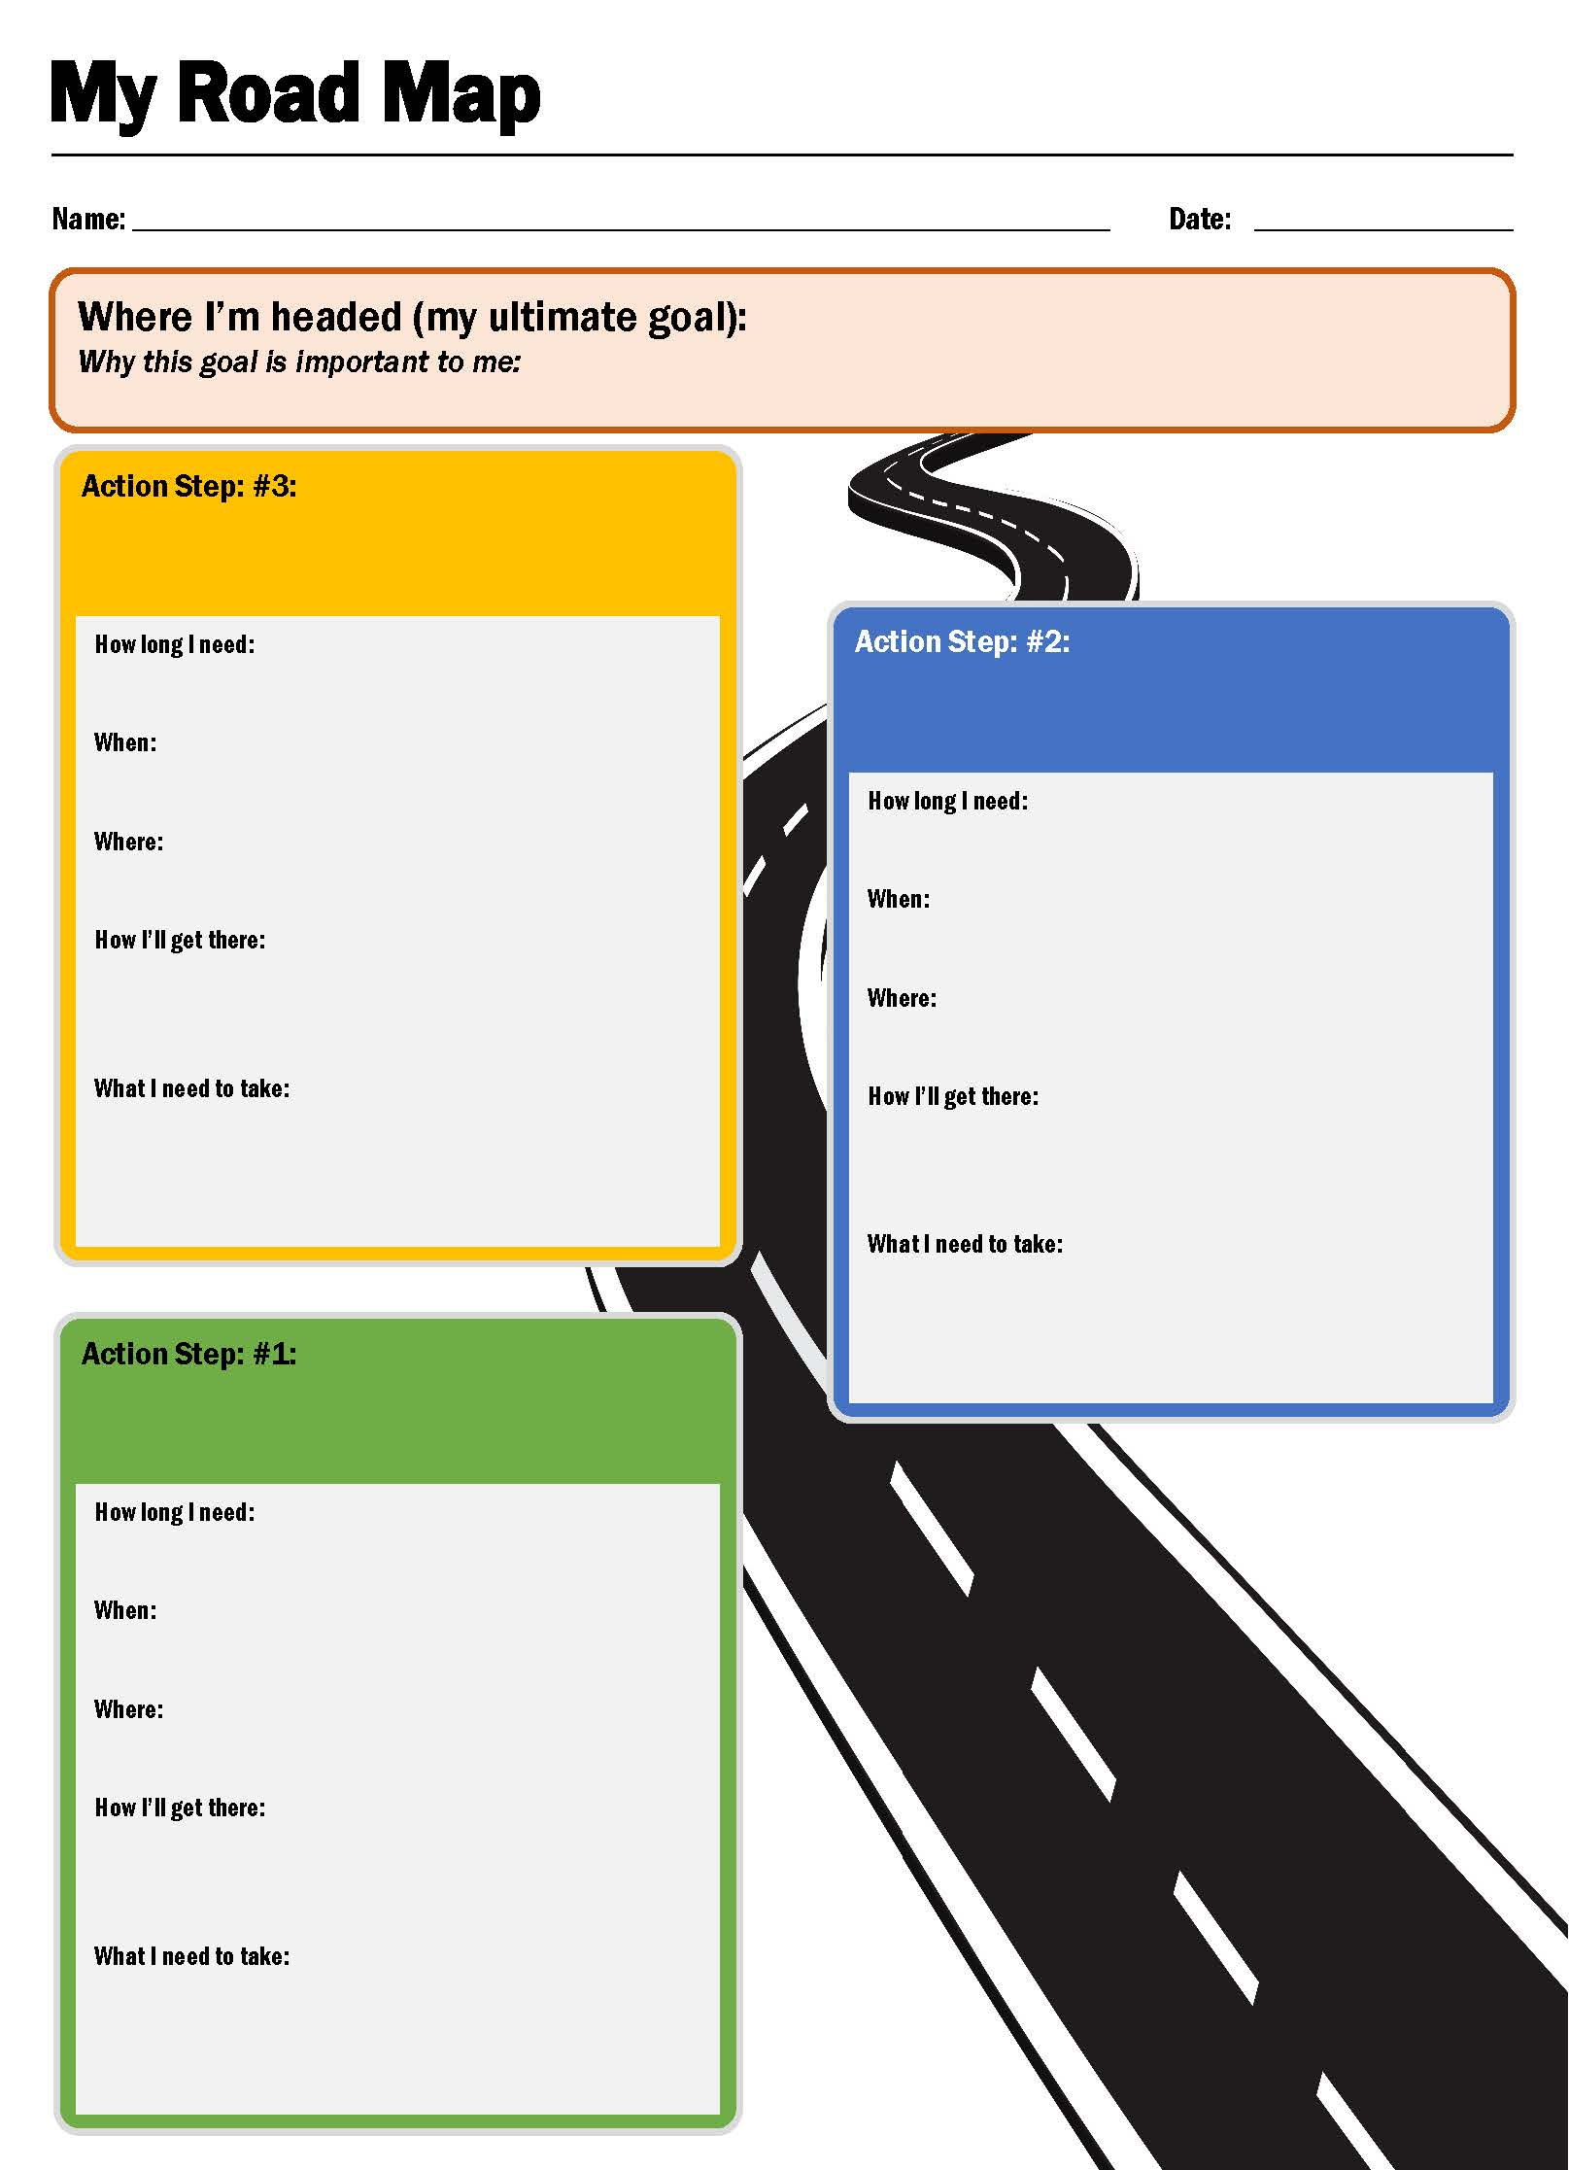

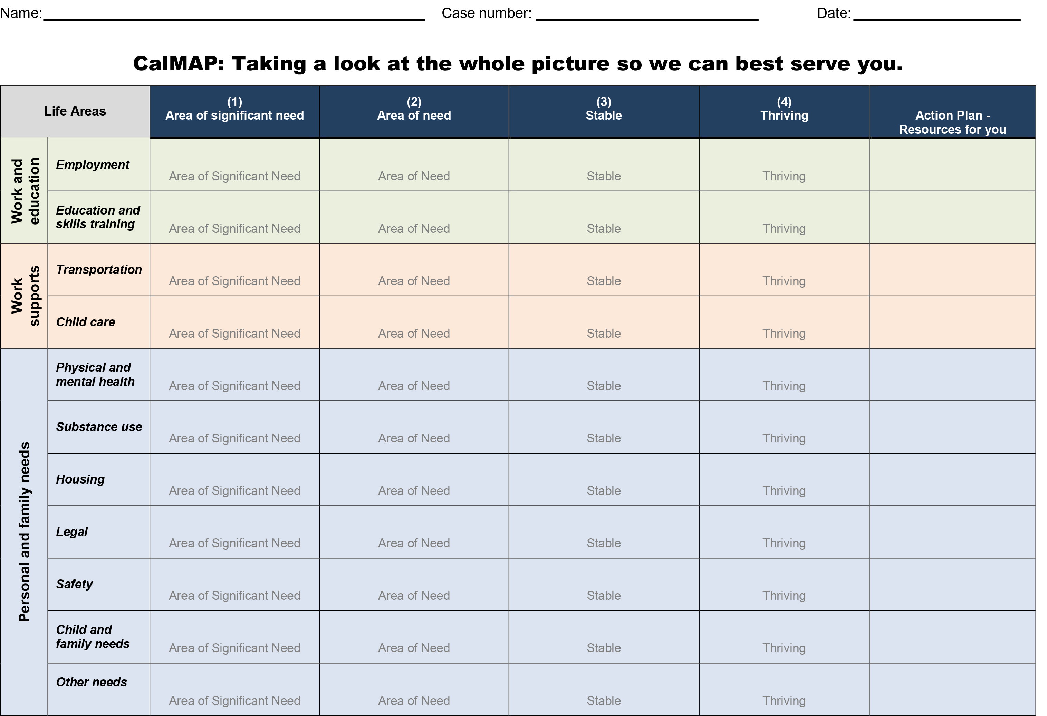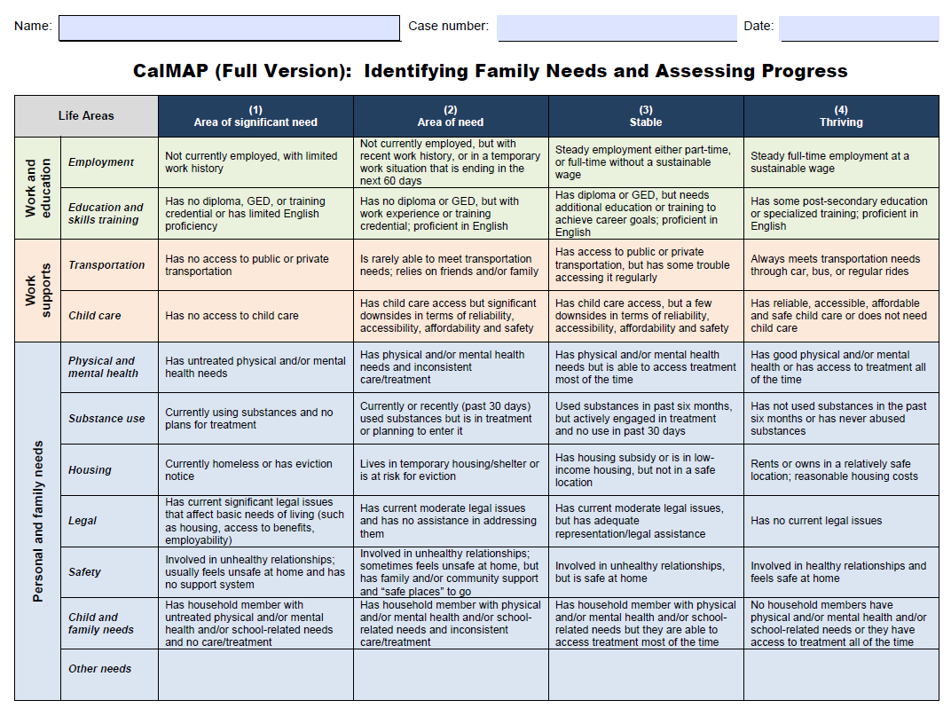

Plan to Use Tools with Clients
 | My Road Map/Potholes & Detours | CalMAP
Client first name

Why this client will benefit from the tool

One next step you will take to make sure the client gets to use this tool

These icons are adapted from B. Farias, The Noun Project. They are all available through Creative Commons.
Center on the Developing Child at Harvard University. “Building Core Capabilities for Life: The Science Behind the Skills Adults Need to Succeed in Parenting and the Workplace.” 2016. Retrieved from www.developingchild.harvard.edu. Accessed 05/25/2018
Note: We use the term Executive Skills when drawing on the work of researchers and practitioners who use that term. For example, the categories on the previous page, and definitions on this page, draw from the work of Dr. Richard Guare and Dr. Peg Dawson, authors of The Smart but Scattered Guide to Success, (Guilford Press, 2016).
Center on the Developing Child, Harvard University, with Frontiers of Innovation. Vital Pictures, 2017. Developingchild.harvard.edu
For more on Executive Skills, explore the interesting resources on CW 2.0 website: http://calworksnextgen.org/category/resource-library/promising-practices/executive-function/
See CalWORKs 2.0 Evidence-to-Practice companion modules on scarcity for a deeper dive.
Vedantam, Shankar. “Hidden Brain.” Tunnel Vision. NPR, 20 Mar. 2017. Web. https://www.npr.org/2017/03/20/520587241/the-scarcity-trap-why-we-keep-digging-when-were-stuck-in-a-hole
International Coaching Federation. “Code of Ethics.” Available at https://coachfederation.org/code-of-ethics.
Adapted from “Family-Centered Coaching: A Toolkit to Transform Practice and Empower Families” by the Building Better Programs, a special initiative of the Center for Budget and Policy Priorities. Available at http://www.buildingbetterprograms.org/wp-content/uploads/2016/12/Family-Centered-Coaching-Toolkit-Draft-Version.pdf.
Material adapted from “Embedding a Strengths Based Approach in Client Conversations” by Kate Pascale and Associates. Available at https://www.emralliance.org/uploads/9/7/7/9/97794766/embedding_a_strengths_based_approach_in_client_conversations.pdf.
DeCandia, C., K. Guarino, and R. Clervil. “Trauma-Informed Care and Trauma-Specific Services: A Comprehensive Approach to Trauma Intervention.” Washington, DC: American Institutes for Research, 2014. Available at https://www.air.org/sites/default/files/downloads/report/Trauma-Informed%20Care%20White%20Paper_October%202014.pdf.
Menschner C., and A. Maul. “Key Ingredients for Successful Trauma-Informed Care Implementation.” Center for Health Care Strategies and the Robert Wood Johnson Foundation, 2016. Available at http://www.chcs.org/media/ATC_whitepaper_040616.pdf.
Adapted from “Goal4 It!TM Motivational Interviewing” by Mathematica Policy Research.

